Microsoft Cloud Workshops

Optimized Architecture Hackathon

Lab guide

February 2017

© 2017 Microsoft Corporation. All rights reserved. This document is confidential and proprietary to Microsoft. Internal use only. This document is for informational purposes only. MICROSOFT MAKES NO WARRANTIES, EXPRESS OR IMPLIED, IN THIS SUMMARY.

This document is provided "as-is." Information and views expressed in this document, including URL and other Internet Web site references, may change without notice. You bear the risk of using it.

Some examples are for illustration only and are fictitious. No real association is intended or inferred.

## Contents

Optimized Architecture hackathon 1

Optimized Architecture hackathon answers 20

# Optimized Architecture hackathon

## Overview

The Optimized Architecture Hackathon is a hands-on exercise that will challenge you to calculate Azure spending optimizations by comparing IaaS and PaaS services using a supplied sample application (a 3-tier application written in C# and ASP.NET MVC) that is based on Microsoft Azure IaaS services such as Virtual Machines, Virtual Network, Load Balancers, Storage and SQL Database. In addition to calculating estimated Azure cost of the existing architecture, you will need to calculate the estimated cost of hosting the sample application using Azure PaaS services. The scenario will include migrating the full sample application to be hosted on Azure PaaS services such as Azure App Service Web Apps, Web Jobs, and Traffic Manager, as well as implementing a secondary hosting region for the Web App tier and database replication.

The Hackathon can be implemented on your own, but it is highly recommended to pair up with other members at the Hackathon to model a real-world experience much closer and to allow each member to share their expertise for the overall solutions.

## Requirements

* Microsoft Azure subscription
* Local machine or a virtual machine configured with:
  + Visual Studio 2015 Community Edition
  + Azure SDK 2.9 for Visual Studio
    - <http://go.microsoft.com/fwlink/?linkid=518003&clcid=0x409>

## Lab structure

This lab has two sets of instructions. The first is a high-level set of instructions that is designed for attendees that have previous experience with Microsoft Azure, and managing and building .NET web apps. The second is a traditional hands-on lab guide that is designed for attendees that do not.

## Exercise 1: Environment setup

In this exercise, you will set up an environment to use for the rest of the exercises.

### Task 1: Setup a Development Environment

If you do not have a machine setup with Visual Studio 2015 Community and Azure SDK 2.9 complete this task.

1. Create a virtual machine in Azure using the Visual Studio Community 2015 Update 3 with Azure SDK 2.9 on Windows Server 2012 R2 image.

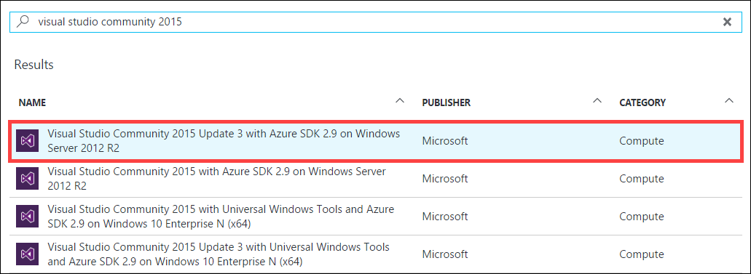

It is **highly** recommended to use a DS2 or D2 instance size for this VM

### Task 2: Disable IE Enhanced Security

Note: Sometimes this image has IE ESC disabled. Sometimes it does not.

1. On the new VM, you just created click the Server Manager icon.



1. Click Local Server

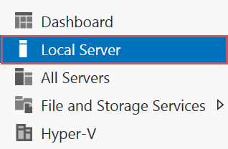

1. On the right side of the pane, click **On** by IE Enhanced Security Configuration.



1. Change to **Off** for Administrators and click **OK**.

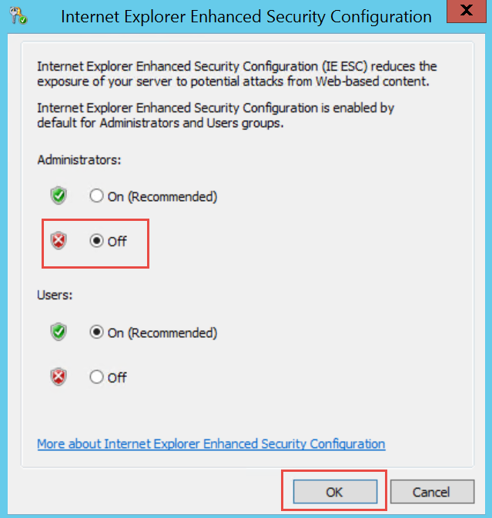

### Task 3: Download the Sample App Files

1. Create a new folder on your C: drive named **Hackathon**.
2. Download the sample application and ARM template from here: https://opsgilityweb.blob.core.windows.net/cebootcamp-feb-2017/Optimize%20the%20Architecture%20Hackathon%20-%20Student%20Files.zip and extract to the **Hackathon** folder.

**Note:** The link above is case sensitive.

1. From the **ARMTemplate** folder under **Hackathon**, open the Visual Studio Solution file: **Contoso.Financial.ARMTemplate.sln**

### Task 4: Deploy Sample App and “Existing” Environment

1. From the *C:\Hackathon\ARMTemplate* folder, open the Visual Studio Solution: **Contoso.Financial.ARMTemplate.sln**
2. In the **Solution Explorer** window, right-click on the **Contoso.Financial.ARMTemplate** project, click **Deploy**, and then click **New Deployment…**  
   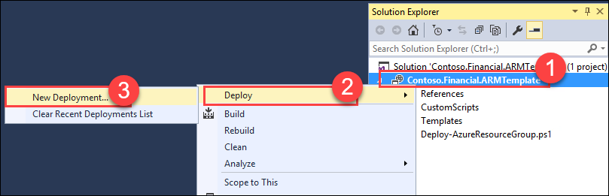
3. If your Microsoft or Organization account for your Azure Subscription has not been added to Visual Studio yet, click on **Add an account**, then **Add an account…**, then follow the prompts to login.  
   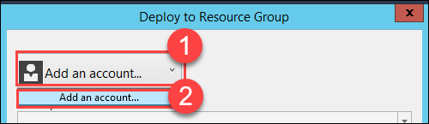
4. Click on the **Resource group** dropdown, then click **<Create New…>**

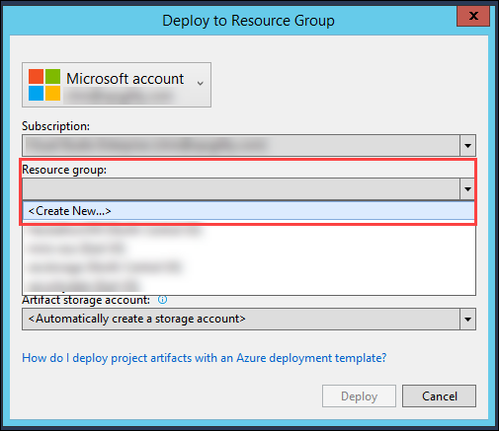

1. On the **Create Resource Group** dialog, enter the following values:
   * Resource group name: **ContosoExistingRG**
   * Resource group location: **North Central US**  
     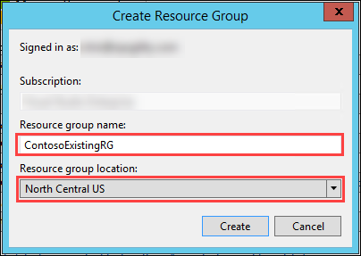
2. Click the **Create** button.
3. On the **Deploy to Resource Group** dialog, click the **Deploy** button to deploy the ARM Template to the newly created Resource Group.  
   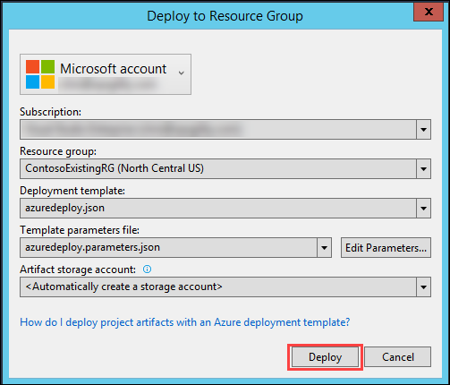
4. Deployment status of the ARM Template will be displayed in the **Output** window within Visual Studio.

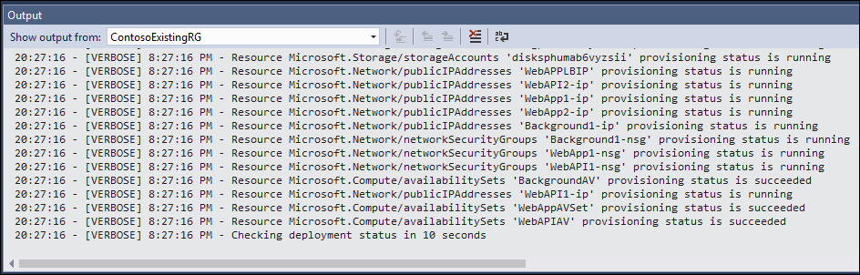

1. Once the deployment has completed successfully, the **IP Address** and **FQDN** of the External / Internet Load Balancer for the Web App tier will be displayed in the output window.  
   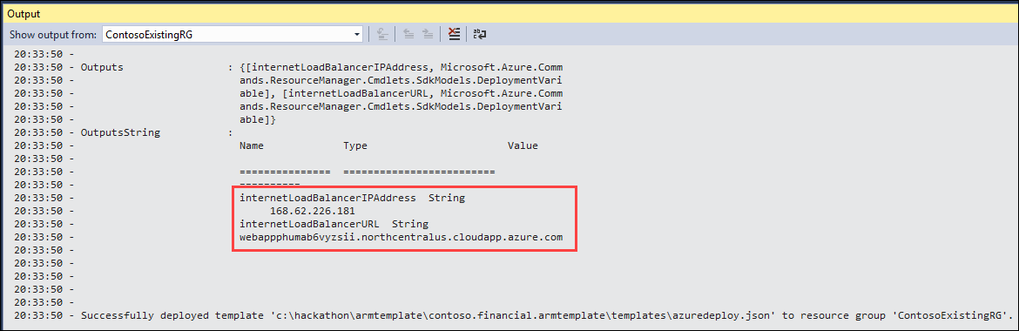

The **Username** and **Password** for the VMs and SQL Database created by the ARM Template are:  
Username: **demouser**

Password: **demo@pass123**

1. Open a new **Web Browser** window and navigate to the Web App tier using the **Internet Load Balancer IP Address**.  
     
   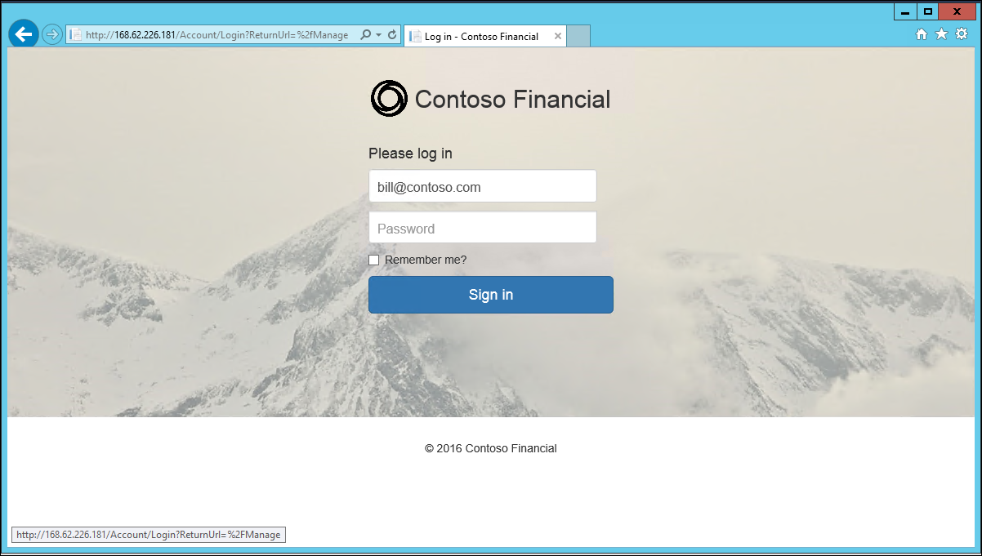
2. To login to the Web App Tier of the Contoso Financial sample application, simply enter **any email address and password**, then click **Sign in**.
3. Once logged in, the sample application will display a simple **Account Transaction** ledger.  
     
   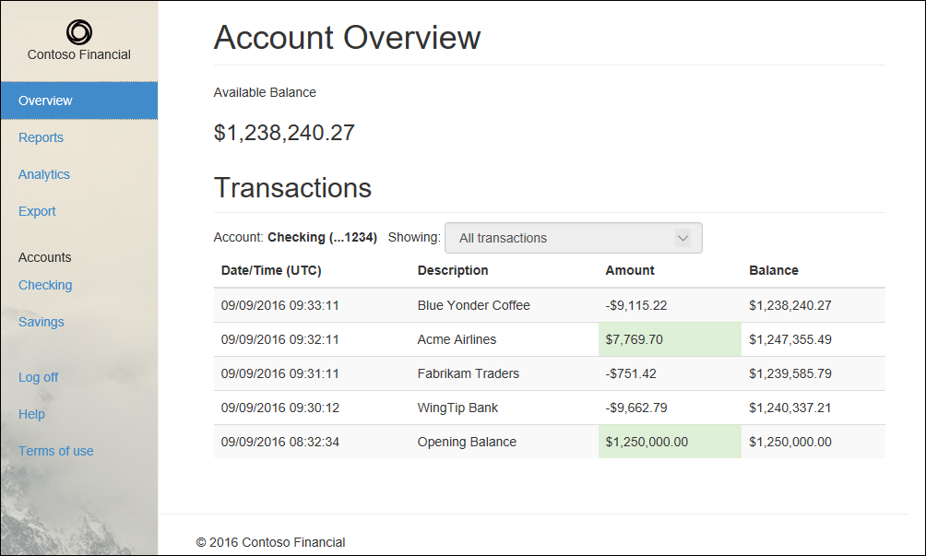

Leaving the browser open to the Account Overview page will automatically load new transactions as they are generated by the background process, since the web page has a JavaScript timer that checks for new transactions periodically.

## Exercise 2: Determine Appropriate App Service Tiers and Estimate Cost Savings

Contoso Financial has asked you to optimize their Azure spending by migrating their existing Azure IaaS based architecture over to Azure PaaS services. You will need to determine the appropriate hosting tiers and estimate the total cost savings on a monthly and annual basis.

### Help references

|  |  |
| --- | --- |
| Azure Pricing Calculator | <https://azure.microsoft.com/en-us/pricing/calculator> |
| Virtual Machines Pricing | <https://azure.microsoft.com/en-us/pricing/details/virtual-machines/> |
| App Service Pricing | <https://azure.microsoft.com/en-us/pricing/details/app-service> |

### Scenario

Contoso Financial recently performed a lift-and-shift to move their application into Microsoft Azure using the North Central US region. As a result, the existing architecture of the application is implemented with Virtual Machines, Load Balancers, Availability Sets, SQL Database, and Virtual Network.

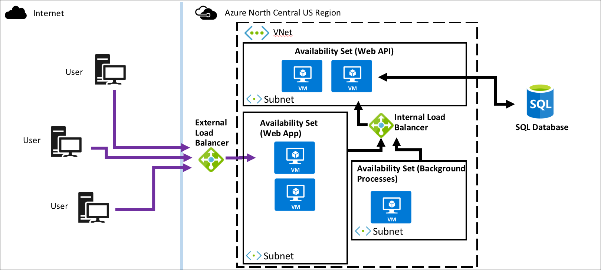

You have also been provided with the following metrics showing the average CPU / RAM utilization of the Virtual Machines hosting the solution that are all on the Standard D3 pricing tier.

When calculating the pricing for the environment, there may be some differences depending if you use the prices listed in the Azure Portal or the Azure Pricing Calculator.

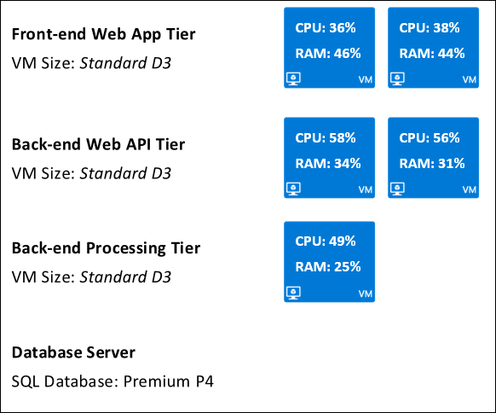

Additionally, the Azure SQL Database is hosted using the Premium P4 pricing tier.

The VM sizes from the Existing architecture that was deployed using the ARM Template will be slightly different from the diagram above for this scenario. The reason for this was to make the ARM Template deployment quicker and cheaper, while still deploying enough to allow you to perform the exercises in this lab.

### Task 1: Calculate Estimated Hosting Cost

### Tasks to complete

* Calculate the estimated hosting cost of the existing architecture
  + Factor in the Virtual Machine instances and SQL Database of the Existing Architecture

### Exit criteria

* Have an estimate of the total estimated Azure cost to hosting the sample application in the Existing Architecture.

### Task 2: Estimate Necessary App Service Tiers

### Tasks to complete

* Estimate the necessary Azure App Service Plan for hosting the sample application in Azure PaaS services
  + Factor in the App Service Plans / instances and SQL Database

### Exit criteria

* Determine the appropriate App Service Plan pricing tier necessary to host the application while maintaining the ability to handle existing application load.

### Task 3: Calculate Estimated Hosting Cost of Azure App Service

### Tasks to complete

* Calculate the estimated hosting cost of the sample application using Azure App Service.

### Exit criteria

* Have an estimate of the total estimated Azure cost to hosting the sample application using Azure App Service.

### Task 4: Calculate Estimated Cost Savings

### Tasks to complete

* Calculate the total estimated cost savings between the existing IaaS architecture and migrating to Azure App Service

### Exit criteria

* Determine both the Monthly and Annual cost savings comparing the cost of both the Existing Architecture and the new Azure App Service architecture.

## Exercise 3: Integrate Traffic Manager

Contoso Financial needs a new load balancing solutions implemented using Azure Traffic Manager. The existing architecture uses a Load Balancer, but that does not accommodate the growth of Contoso Financial appropriately where they will need to add additional hosting regions in Europe.

### Help references

|  |  |
| --- | --- |
| Azure Load Balancer | <https://azure.microsoft.com/en-us/services/load-balancer/> |
| Azure Traffic Manager | <https://azure.microsoft.com/en-us/services/virtual-network/> |

### Task 1: Create Traffic Manager

### Tasks to complete

* Setup Traffic Manager to point to the Front-end Web App tier of the sample application

### Exit criteria

* A Traffic Manager has been created in the Azure Subscription within the North Central US region

### Task 2: Point Traffic Manager to External / Internet Load Balancer

### Tasks to complete

* Configure the Traffic Manager to integrate with the External Load Balancer for the Front-end Web App tier.

### Exit criteria

* Have a Traffic Manager endpoint that can be used to access the Front-end Web App tier configured through the existing External Load Balancer.

## Exercise 4: Setup API Tier in Azure App Service

### Task 1: Create App Service for Web API Tier

### Tasks to complete

* Setup an App Service instance to use for hosting the Web API tier

### Exit criteria

* An App Service instance has been created in the North Central US region.

### Task 2: Setup App Settings

### Tasks to complete

* Setup the Application Settings to configure the Connection String named “TransactionDb” to contain the connection string for the sample applications SQL Database

### Exit criteria

* The Application Settings Connection String has been configured.

### Task 3: Deploy API to App Service

### Tasks to complete

* Deploy the API tier of the sample application (located within the Contoso.Financial.Api project within the Contoso.Financial Visual Studio solution within the hackathon files) into the App Service Web App.

### Exit criteria

* The API tier has been deployed and is accessible.

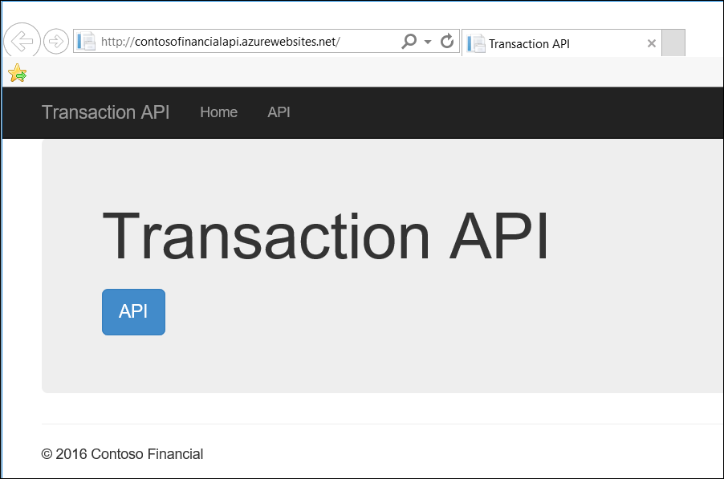

## Exercise 5: Migrate Web App Tier to App Service

### Task 1: Create App Service for Web App Tier

### Tasks to complete

* Setup an App Service instance to use for hosting the Web App tier

### Exit criteria

* An App Service instance has been created in the North Central US region.

### Task 2: Setup App Settings

### Tasks to complete

* Setup the Application Settings to configure the App Setting named “transactionAPIUrl” to contain the URL to the API tier hosted in App Service.

### Exit criteria

* The Application Settings App Setting has been configured.

### Task 3: Deploy App to Web App

### Tasks to complete

* Deploy the Web App tier of the sample application (located within the Contoso.Financial.Web project within the Contoso.Financial Visual Studio solution within the hackathon files) into the App Service Web App.

### Exit criteria

* The Web App Tier has been deployed and is accessible in a web browser.

### Task 4: Add Web App to Traffic Manager

### Tasks to complete

* Configure a Traffic Manager Endpoint for the new App Service hosted Web App Tier of the application.
* Remove the External Load Balancer Endpoint from the Traffic Manager.

### Exit criteria

* The Traffic Manager Endpoint has been configured for the App Service Web App Tier, and is accessible in a web browser.
* The External Load Balancer Endpoint has been removed from Traffic Manager.

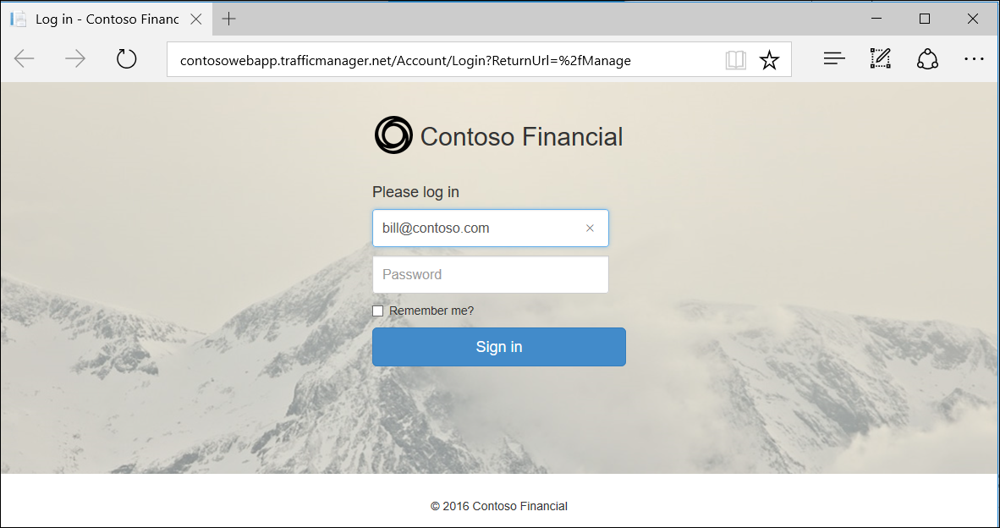

### Task 5: Take down Web App and API VMs

### Tasks to complete

* Stop the Web App tier Virtual Machines.
* Stop the API tier Virtual Machines.

### Exit criteria

* The Virtual Machines hosting the Web App and API tiers of the sample application are in a “Stopped (deallocated)” state.

## Exercise 6: Migrate Background Tier to App Service

### Task 1: Create App Service for Background Tier

### Tasks to complete

* Setup an App Service instance to use for hosting the Background tier

### Exit criteria

* An App Service instance has been created in the North Central US region.

### Task 2: Setup App Settings

### Tasks to complete

* Setup the Application Settings to configure the Connection String named “TransactionDb” to contain the connection string to the SQL Database.

### Exit criteria

* The Application Settings Connection String has been configured.

### Task 3: Deploy App to App Service

### Tasks to complete

* Deploy the Background tier of the sample application (located within the Contoso.Financial.Background project within the Contoso.Financial Visual Studio solution within the hackathon files) into the App Service Web App as a Web Job.
* Configure the Web Job to be recurring and scheduled to run every **1 Minutes**.

### Exit criteria

* The Background tier has been deployed.
* The Background tier is scheduled to run every 1 minute.

### Task 4: Take down Background Tier VM

### Tasks to complete

* Stop the Background tier Virtual Machine.

### Exit criteria

* The Virtual Machine hosting the Background tier of the sample application is in a “Stopped (deallocated)” state.

## Exercise 7: Setup SQL Database Geo-Replication

### Task 1: Setup SQL Database Geo-Replication

### Tasks to complete

* Configure the SQL Database with Active Geo-Replication

### Exit criteria

* The SQL Database has been configured with Active Geo-Replication.

## Exercise 8: Take down old architecture / resources

### Task 1: Remove old VM-based tiers

### Tasks to complete

* Remove all the Existing Architecture resources that are no longer being used after the migration to Azure PaaS services.

### Exit criteria

* The Azure resources for the Virtual Network and Virtual Machines of the Existing Architecture have been removed.
* The SQL Database remains.

## Exercise 9: Setup European Web App Tier Instance

### Task 1: Create European App Service

### Tasks to complete

* Setup an App Service instance to use for hosting the Web App tier in the Azure North Europe region.

### Exit criteria

* An App Service instance has been created in the North Europe region.

### Task 2: Set App Settings

### Tasks to complete

* Setup the Application Settings to configure the App Setting named “transactionAPIUrl” to contain the URL to the API tier hosted in App Service.

### Exit criteria

* The Application Settings App Setting has been configured.

### Task 3: Deploy Web App to European Region

### Tasks to complete

* Deploy the Web App tier of the sample application (located within the Contoso.Financial.Web project within the Contoso.Financial Visual Studio solution within the hackathon files) into the App Service Web App.

### Exit criteria

* The Web App Tier has been deployed to the North Europe region and is accessible in a web browser.

### Tasks 4: Add European Region to Traffic Manager

### Tasks to complete

* Configure a Traffic Manager Endpoint for the new App Service hosted Web App Tier of the application in the North Europe region.

### Exit criteria

* The Traffic Manager Endpoint has been configured for the App Service Web App Tier, and is accessible in a web browser.
* The Traffic Manager Endpoint for the App Service Web App Tier in the North Central US region remains.
* The App is accessible through the Traffic Manager endpoint.

# Optimized Architecture hackathon answers

## Overview

This portion of the lab is designed to help *only* if you are blocked or do not have any experience with Azure tools or services.

## Exercise 1: Environment setup

In this exercise, you will set up an environment to use for the rest of the exercises.

### Task 1: Setup a Development Environment

If you do not have a machine setup with Visual Studio 2015 Community and Azure SDK 2.9 complete this task.

1. Create a virtual machine in Azure using the Visual Studio Community 2015 Update 3 with Azure SDK 2.9 on Windows Server 2012 R2 image.



It is **highly** recommended to use a DS2 or D2 instance size for this VM

### Task 2: Disable IE Enhanced Security

Note: Sometimes this image has IE ESC disabled. Sometimes it does not.

1. On the new VM, you just created click the Server Manager icon.



1. Click Local Server



1. On the right side of the pane, click **On** by IE Enhanced Security Configuration.



1. Change to **Off** for Administrators and click **OK**.



### Task 3: Download the Sample App Files

1. Create a new folder on your C: drive named **Hackathon**.
2. Download the sample application and ARM template (optimized-architecture-student.zip) from here: <http://bit.ly/2d6i6iX> and extract to the **Hackathon** folder.

**Note:** The link above is case sensitive.

1. From the **ARMTemplate** folder under **Hackathon**, open the Visual Studio Solution file: **Contoso.Financial.ARMTemplate.sln**

### Task 4: Deploy Sample App and “Existing” Environment

1. From the *C:\Hackathon\ARMTemplate* folder, open the Visual Studio Solution: **Contoso.Financial.ARMTemplate.sln**
2. In the **Solution Explorer** window, right-click on the **Contoso.Financial.ARMTemplate** project, click **Deploy**, and then click **New Deployment…**  
   
3. If your Microsoft or Organization account for your Azure Subscription has not been added to Visual Studio yet, click on **Add an account**, then **Add an account…**, then follow the prompts to login.  
   
4. Click on the **Resource group** dropdown, then click **<Create New…>**



1. On the **Create Resource Group** dialog, enter the following values:
   * Resource group name: **ContosoExistingRG**
   * Resource group location: **North Central US**  
     
2. Click the **Create** button.
3. On the **Deploy to Resource Group** dialog, click the **Deploy** button to deploy the ARM Template to the newly created Resource Group.  
   
4. Deployment status of the ARM Template will be displayed in the **Output** window within Visual Studio.



1. Once the deployment has completed successfully, the **IP Address** and **FQDN** of the External / Internet Load Balancer for the Web App tier will be displayed in the output window.  
   

The **Username** and **Password** for the VMs and SQL Database created by the ARM Template are:  
Username: **demouser**

Password: demo@pass123

1. Open a new **Web Browser** window and navigate to the Web App tier using the **Internet Load Balancer IP Address**.  
     
   
2. To login to the Web App Tier of the Contoso Financial sample application, simply enter **any email address and password**, then click **Sign in**.
3. Once logged in, the sample application will display a simple **Account Transaction** ledger.  
     
   

Leaving the browser open to the Account Overview page will automatically load new transactions as they are generated by the background process, since the web page has a JavaScript timer that checks for new transactions periodically.

## Exercise 2: Determine Appropriate App Service Tiers and Estimate Cost Savings

### Overview

Contoso Financial has asked you to optimize their Azure spending by migrating their existing Azure IaaS based architecture over to Azure PaaS services. You will need to determine the appropriate hosting tiers and estimate the total cost savings on a monthly and annual basis.

### Help references

|  |  |
| --- | --- |
| Azure Pricing Calculator | <https://azure.microsoft.com/en-us/pricing/calculator> |
| Virtual Machines Pricing | <https://azure.microsoft.com/en-us/pricing/details/virtual-machines/> |
| App Service Pricing | <https://azure.microsoft.com/en-us/pricing/details/app-service> |

### Scenario

Contoso Financial recently performed a lift-and-shift to move their application into Microsoft Azure using the North Central US region. As a result, the existing architecture of the application is implemented with Virtual Machines, Load Balancers, Availability Sets, SQL Database, and Virtual Network.



You have also been provided with the following metrics showing the average CPU / RAM utilization of the Virtual Machines hosting the solution that are all on the Standard D3 pricing tier.

When calculating the pricing for the environment, there may be some differences depending if you use the prices listed in the Azure Portal or the Azure Pricing Calculator.



Additionally, the Azure SQL Database is hosted using the Premium P4 pricing tier.

The VM sizes from the Existing architecture that was deployed using the ARM Template will be slightly different from the diagram above for this scenario. The reason for this was to make the ARM Template deployment quicker and cheaper, while still deploying enough to allow you to perform the exercises in this lab.

### Task 1: Calculate Estimated Hosting Cost

1. From a new browser tab or instance, navigate to the **Azure Pricing Calculator** <https://azure.microsoft.com/en-us/pricing/calculator>
2. Click on **Compute**, then **Virtual Machines**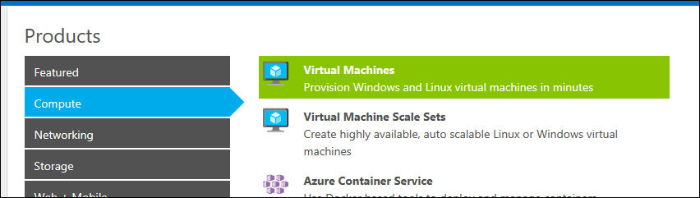
3. Click on **Databases**, then **SQL Database**  
     
   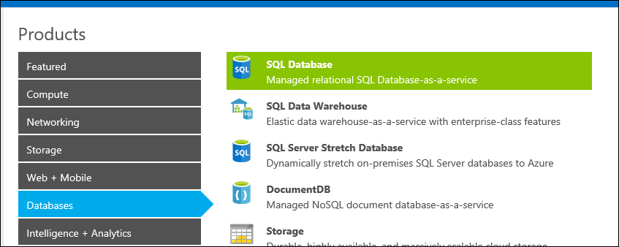
4. Click the **View estimate** link.  
     
   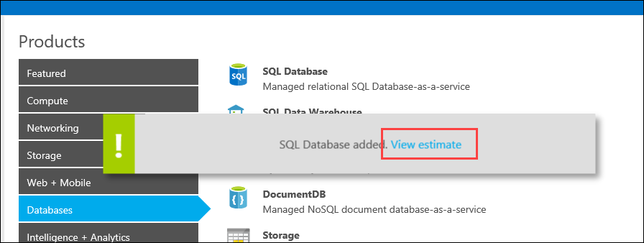
5. On the **SQL Database**, set the following values:
   * Region: **North Central US**
   * Pricing Tier: **Premium**

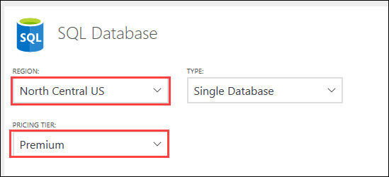

1. Set the **Performance Level** to **P4**.  
     
   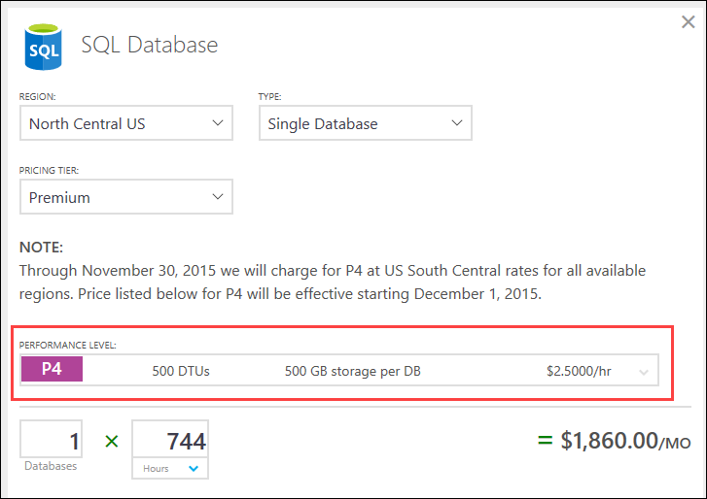
2. On **Virtual Machines**, set the following values:
   * Region: **North Central US**
   * Pricing Tier: **Standard**

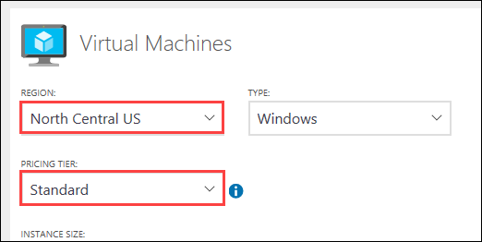

1. Change the **Instance Size** to **D3**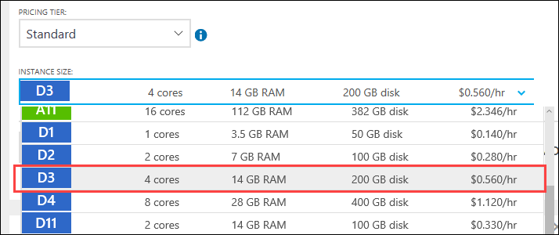
2. Change the **Virtual Machines Count** to **5**, so that the count includes the 2x Web App Tier, 2x API Tier, and 1x Background Tier virtual machines.  
     
   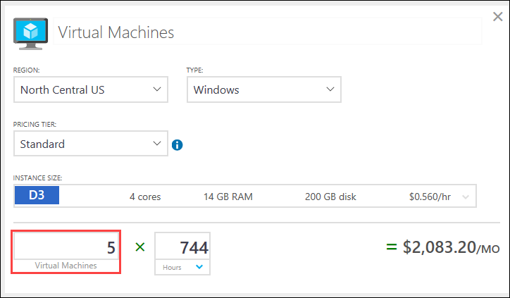
3. Record the **Estimated monthly cost**. This is the total estimated cost of the existing environment Virtual Machines and SQL Database only.  
     
   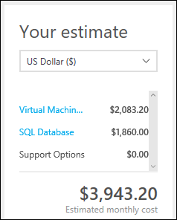

### Task 2: Estimate Necessary App Service Tiers

#### Subtask 1: Find Existing VM Instance Size Specifications (CPU Cores and RAM)

1. From a new browser tab or instance, navigate to the **Virtual Machines Pricing** page <https://azure.microsoft.com/en-us/pricing/details/virtual-machines/>
2. Set the following filters on the **Pricing** page:
   * OS/Software: **Windows OS**
   * Region: **North Central US**

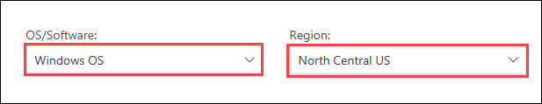

1. Click on and expand the **General Purpose** section  
     
   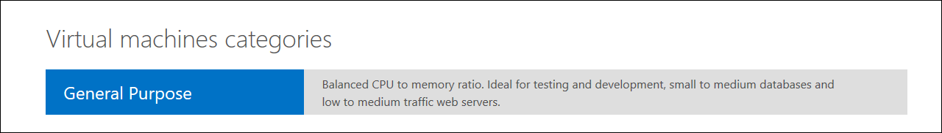
2. Scroll down to the **D1-4 v1** section and make note of the VM Instance specs, specifically the **CPU Cores** and **RAM** for the **D3** instance size.  
     
   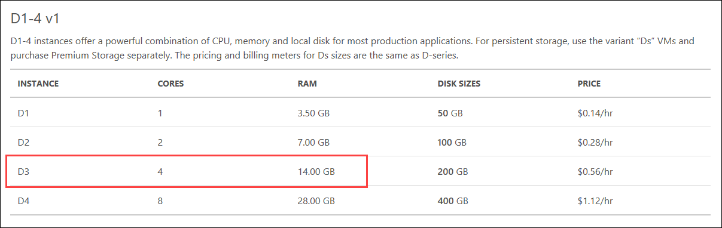

#### Subtask 2: Calculate Web App Tier VM Utilization

1. Calculate the **Average CPU Utilization** between the 2 Web App Tier VMs with individual CPU utilization of **36%** and **38%**.
   * 36 + 38 = 74
   * 74 / 2 = **37% Average CPU Utilization**

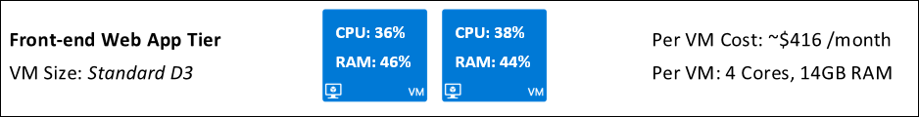

1. Calculate the amount of **CPU Cores** the **Average CPU Utilization** represents:
   * **4** (CPU Cores) **\* 0.37** (37%) **= 1.48 CPU Cores**
2. Calculate the **Average RAM Utilization** between the 2 Web App Tier VMs with individual RAM Utilization of **46%** and **44%**.
   * 46 + 44 = 90
   * 90 / 2 = **45% Average RAM Utilization**
3. Calculate the amount of **RAM** the **Average RAM Utilization** represents:
   * **14 GB** (RAM) **\* 0.45** (45%) **= 6.3 GB RAM**

#### Subtask 3: Calculate API Tier VM Utilization

1. Calculate the **Average CPU Utilization** between the 2 API Tier VMs with individual CPU utilization of **58%** and **56%**.
   * 58 + 56 = 114
   * 114 / 2 = **57% Average CPU Utilization**

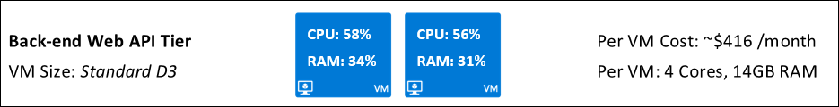

1. Calculate the amount of **CPU Cores** the **Average CPU Utilization** represents:
   * **4** (CPU Cores) **\* 0.57** (57%) **= 2.28 CPU Cores**
2. Calculate the **Average RAM Utilization** between the 2 API Tier VMs with individual RAM utilization of **34%** and **31%**.
   * 34 + 31 = 65
   * 65 / 2 = **32.5% Average RAM Utilization**
3. Calculate the amount of **RAM** the **Average RAM Utilization** represents:
   * **14 GB** (RAM) **\* 0.325** (32.5%) **= 4.55 GB RAM**

#### Subtask 4: Calculate Background Tier VM Utilization

1. The **Average CPU Utilization** of the single Background Tier VM is **49%**.  
     
   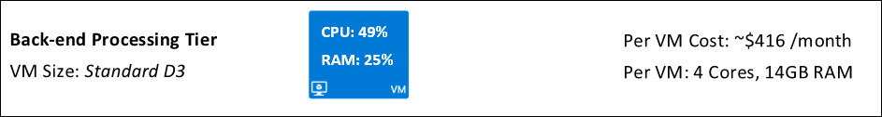
2. Calculate the amount of **CPU Cores** the **Average CPU Utilization** represents:
   1. **4** (CPU Cores) **\* 0.49** (49%) **= 1.96 CPU Cores**
3. The **Average RAM Utilization** of the single Background Tier VM is **25%**.
4. Calculate the amount of **RAM** the **Average RAM Utilization** represents:
   1. **14 GB** (RAM) **\* 0.25** (25%) **= 3.5 GB RAM**

#### Subtask 5: Identify Appropriate App Service Tier

1. From a new browser tab or instance, navigate to the **App Service Pricing** page <https://azure.microsoft.com/en-us/pricing/details/app-service>
2. Set the **Region** filter to **North Central US**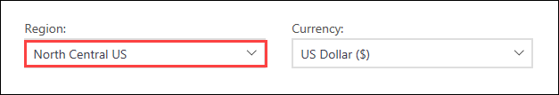
3. Scroll down to the **Standard Service Plan** section  
   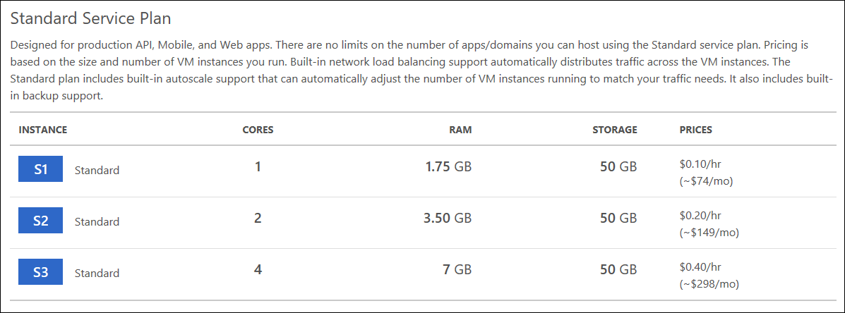
4. Map the **CPU / RAM** **Utilization** of the **Web App Tier** **(1.48 CPU Cores / 6.3 GB RAM)** to the closest **Standard Service Plan** tier. These maps to be the **Standard S3** pricing tier.
5. Map the **CPU / RAM** **Utilization** of the **API Tier** **(2.28 CPU Cores / 4.55 GB RAM)** to the closest **Standard Service Plan** tier. These maps to be the **Standard S3** pricing tier.
6. Map the **CPU / RAM** **Utilization** of the **Background Tier** **(1.96 CPU Cores / 3.5 GB RAM)** to the closest **Standard Service Plan** tier. These maps to be the **Standard S3** pricing tier.

The **Background Tier** matches almost identical to 100% of the CPU / RAM resources of the **Standard S2** pricing tier. However, 100% utilization would hinder the performance of the server since the resources would be at their maximum. For this reason, it is appropriate to go with the **Standard S3** pricing tier instead to leave extra room for best performance and possible spikes in load / usage.

1. Overall, it has been identified that the **Standard S3** is the appropriate **App Service Plan** pricing tier to use for the Web App, API, and Background tiers.

### Task 3: Calculate Estimated Hosting Cost of Azure App Service

1. From a new browser tab or instance, navigate to the **Azure Pricing Calculator** <https://azure.microsoft.com/en-us/pricing/calculator>
2. Click **+Add items** button, then click on **App Service**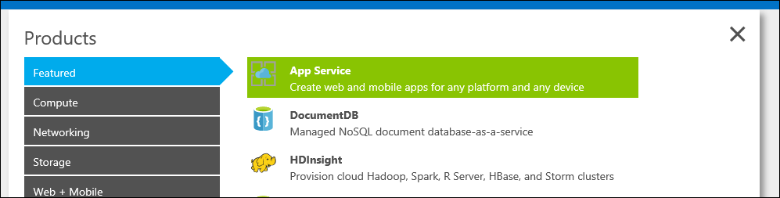
3. Click the **View estimate** link.  
     
   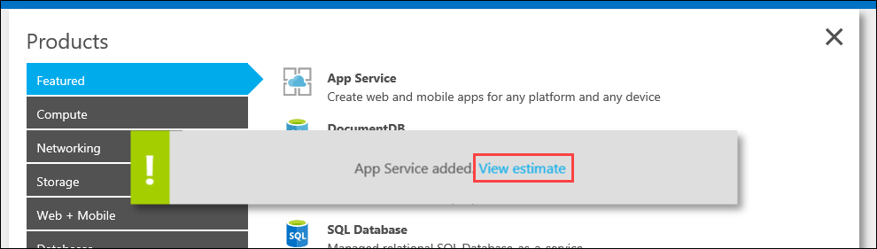
4. If the **Virtual Machines** are still in the calculator from estimating the VM cost, click on the **X** to remove them from the calculator.  
     
   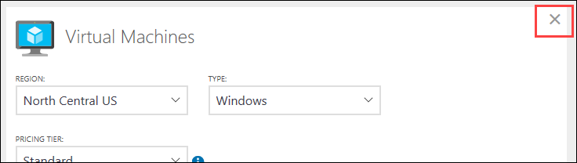
5. If the **SQL Database** is not in the calculator from the previous VM estimation, then click the **+Add items** button and add it back again.  
     
   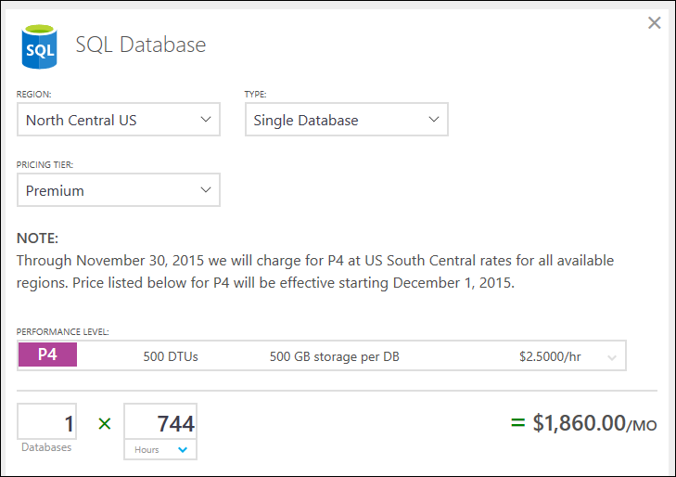
6. On **App Service**, change the **Region** to **North Central US**.  
     
   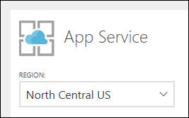
7. Change the **Tier** to **Standard** and the **Instance Size** to **S3** to reflect the App Service Plan tier that was identified as the appropriate hosting tier for the Web App, API, and Background application tiers.  
     
   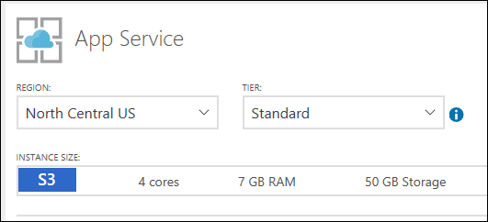
8. Change the **Instances** count to **5** to reflect the same number of instances of the existing VM architecture (2x Web App Tier, 2x API Tier, 1x Background Tier)  
     
   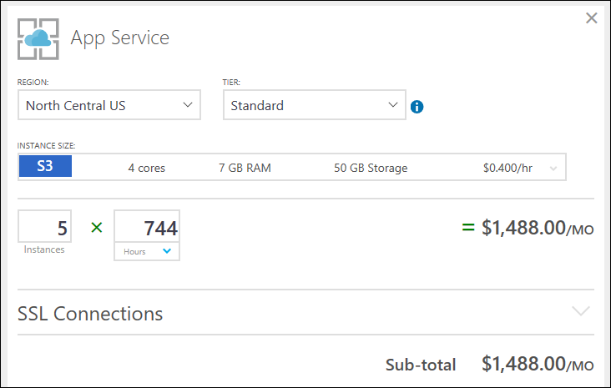

The **Instance Count** should remain **5** since the application will still need the same amount of resources to host; it is just the Azure Service hosting them that is changing. For example: Since the Web App Tier needs 2 VM instances, the App Service Plan will also use 2 instances for hosting.

1. Record the **Estimated monthly cost**. This is the total estimated cost of the new environment App Service Instances and SQL Database only.  
     
   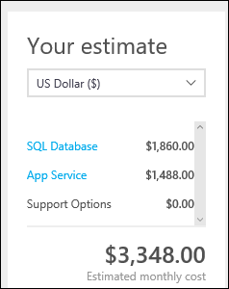

### Task 4: Calculate Estimated Cost Savings

1. Copy the **Estimated Cost** of the **Existing Architecture** (VMs and SQL Database)

The **Existing Architecture** cost that was estimated in the screenshots above came to approximately **$3,943**. Your estimate may vary, depending on current Azure pricing.

1. Copy the **Estimated Cost** of the **New Architecture** (App Service and SQL Database)

The **New Architecture** cost that was estimated in the screenshots above came to approximately **$3,348**. Your estimate may vary, depending on current Azure pricing.

1. **Subtract** the estimated cost of the **New Architecture** from the **Existing Architecture** to calculate the **Estimated Monthly Cost Savings**
   * Existing – New = Estimated Monthly Cost Savings

From the estimates above this would be:

**$3,943 - $3,348 = $595**

Remember your results may vary, depending on current Azure pricing.

1. To calculate the **Annual Cost Savings**, take the **Monthly Cost Savings** and multiply it by **12**.
   * Monthly Cost Savings * 12 = Annual Cost Savings

From the estimates above this would be:

**$595 * 12 = $7,140**

Remember your results may vary, depending on current Azure pricing.

1. Make note that these **Estimated Cost Savings** do not include bandwidth, storage and other charges that will be incurred in hosting the application. The estimates calculated above only pertain to the **App Service Plans** and **SQL Database**.

From the estimates above this would be:

Estimated Monthly Cost Savings: $595

Estimated Annual Cost Savings: $7,140

## Exercise 3: Integrate Traffic Manager

### Overview

Contoso Financial needs a new load balancing solutions implemented using Azure Traffic Manager. The existing architecture uses a Load Balancer, but that does not accommodate the growth of Contoso Financial appropriately where they will need to add additional hosting regions in Europe.

### Help references

|  |  |
| --- | --- |
| Azure Load Balancer | <https://azure.microsoft.com/en-us/services/load-balancer/> |
| Azure Traffic Manager | <https://azure.microsoft.com/en-us/services/virtual-network/> |

### Task 1: Create Traffic Manager

1. From the Azure Management portal <http://portal.azure.com>, using a new tab or instance, click on **+New**, then type **Traffic Manager** into the **Search the marketplace** box and press **Enter**.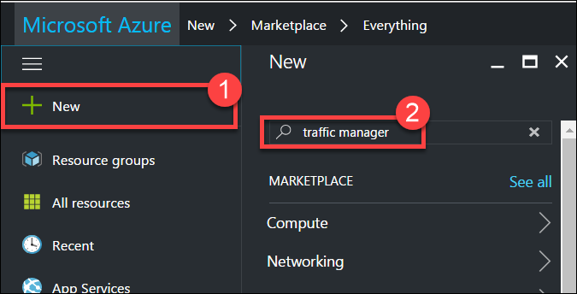
2. Click on **Traffic Manager profile** in the list.  
   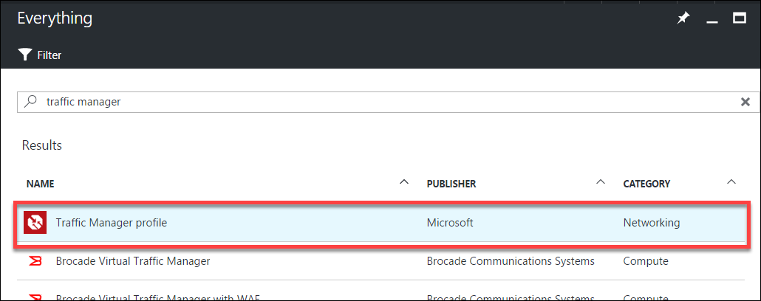
3. Click on **Create**.  
   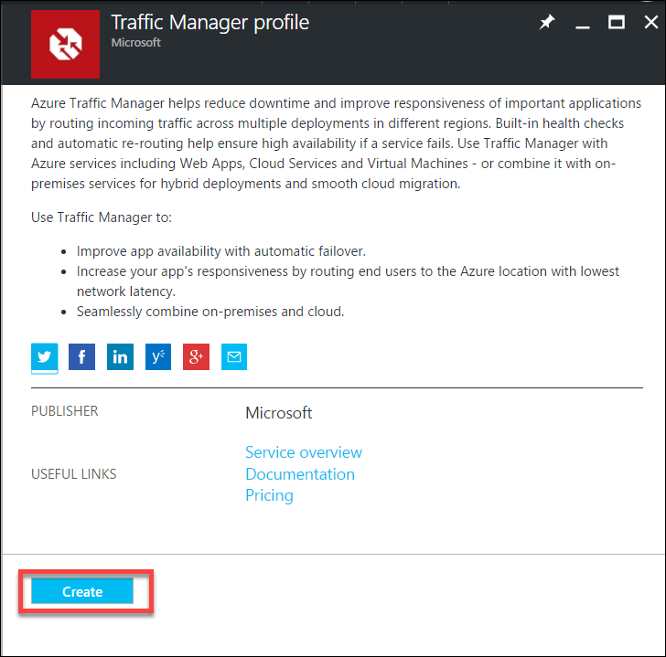
4. On the **Create Traffic Manager profile** blade enter the following values:
   * Name: **enter a unique name for the Traffic Manager**
   * Routing method: **Performance**
   * Resource group: **OptimizedTFRG**
   * Resource group location: **North Central US**  
     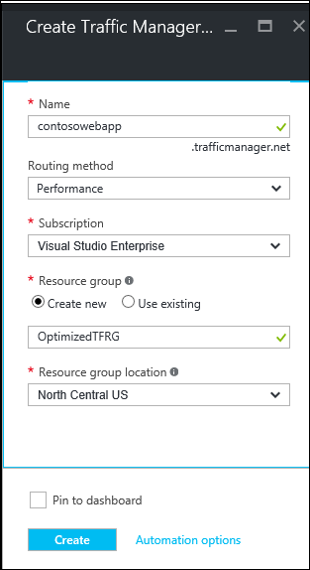
5. Click **Create**

### Task 2: Point Traffic Manager to External / Internet Load Balancer

1. Click on **Resource groups**, click on the **OptimizedTFRG** resource group, then click on the **Traffic Manager** that was just created.  
   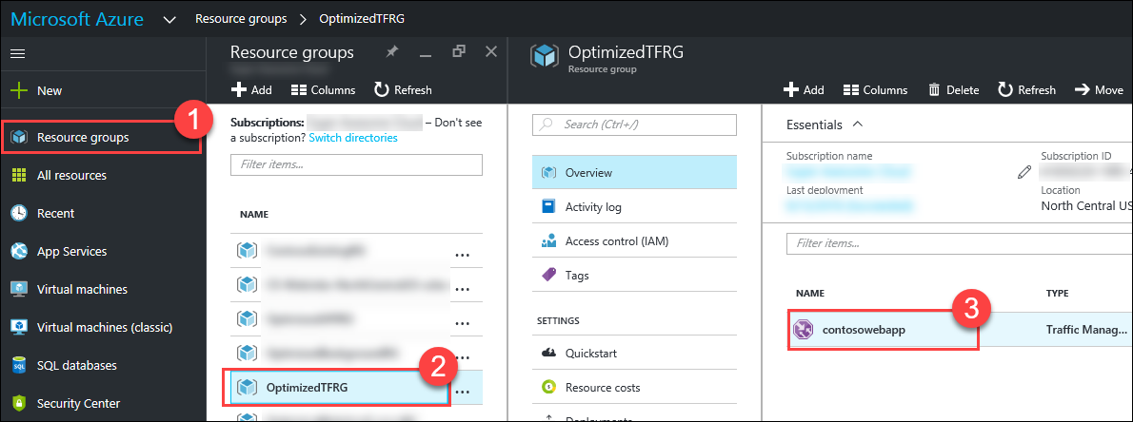
2. On the **Traffic Manager** blade, click on **Endpoints** under Settings.  
     
   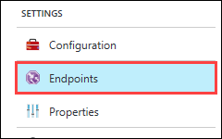
3. On the **Endpoints** blade, click on the **Add** button.  
     
   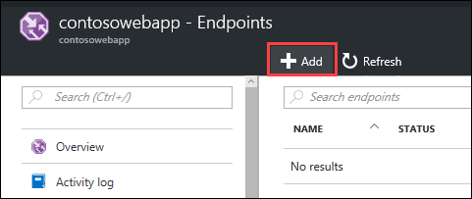
4. On the **Add endpoint** blade, enter the following values:
   * Type: **Azure endpoint**
   * Name: **External Load Balancer**
   * Target resource type: **Public IP address**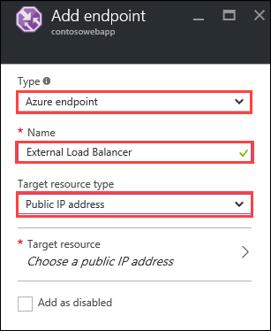
5. Click on **Choose a public IP address**, and then click on the **WebAPPLBIP** IP Address in the **ContosoExistingRG** resource group.  
     
   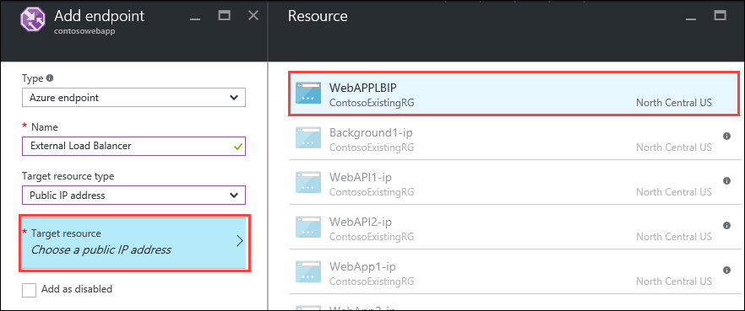
6. Click **OK**
7. Click on **Overview**, then click on the **DNS Name** for the Traffic Manager to navigate to the sample application in a new browser window  
   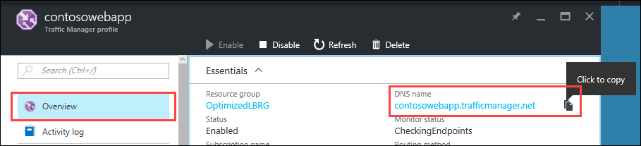
8. The sample application loading will indicate the **Traffic Manager** was configured correctly.  
     
   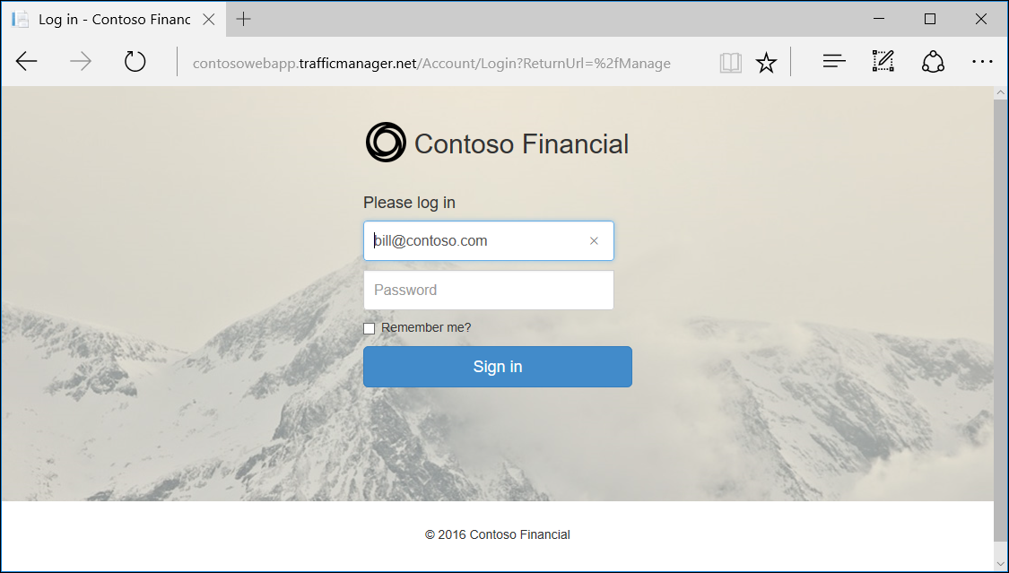

## Exercise 4: Setup API Tier in Azure App Service

### Overview

In the migration of IaaS to PaaS, the API Tier of Contoso Financials application needs to be migrated to run in an Azure App Service Web App without requiring any code changes to the application.

### Help references

|  |  |
| --- | --- |
| API Apps overview | <https://docs.microsoft.com/en-us/azure/app-service-api/app-service-api-apps-why-best-platform> |
| Deploy an ASP.NET web app to Azure App Service, using Visual Studio | <https://azure.microsoft.com/en-us/documentation/articles/web-sites-dotnet-get-started/> |
| Configure web apps in Azure App Service | <https://azure.microsoft.com/en-us/documentation/articles/web-sites-configure/> |

### Step 1: Create App Service for Web API Tier

1. From the Azure Management portal <http://portal.azure.com>, using a new tab or instance, click on **+New**, then type **API App** into the 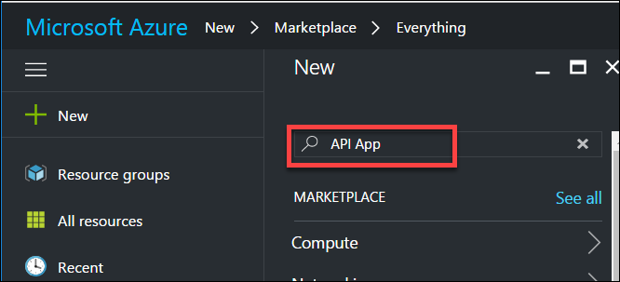
2. On the **Web App** blade, enter the following values:
   * App name: **enter a unique name**
   * Resource group: **OptimizedAPIRG**
   * App Insights: **Off**  
     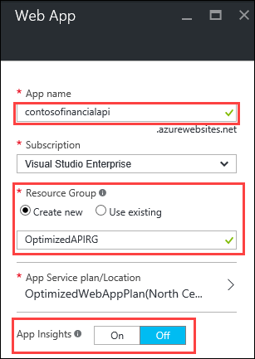
3. Click on **App Service plan/Location**, then **Create New**, and fill in the following values:
   * App Service plan: **OptimizedAPIPlan**
   * Location: **North Central US**
   * Pricing tier: **S1 Standard**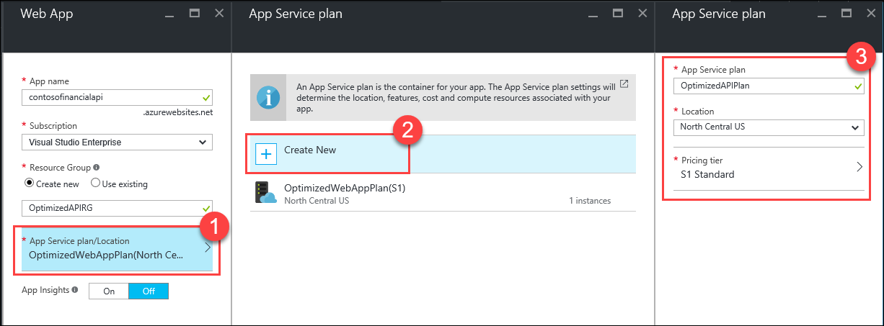
4. Click **OK**
5. Click **Create**

### Step 2: Setup App Settings

1. Click on **Resource groups**, click on the **ContosoExistingRG** resource group, then click on the **contosofinancialdb** SQL Database.  
     
   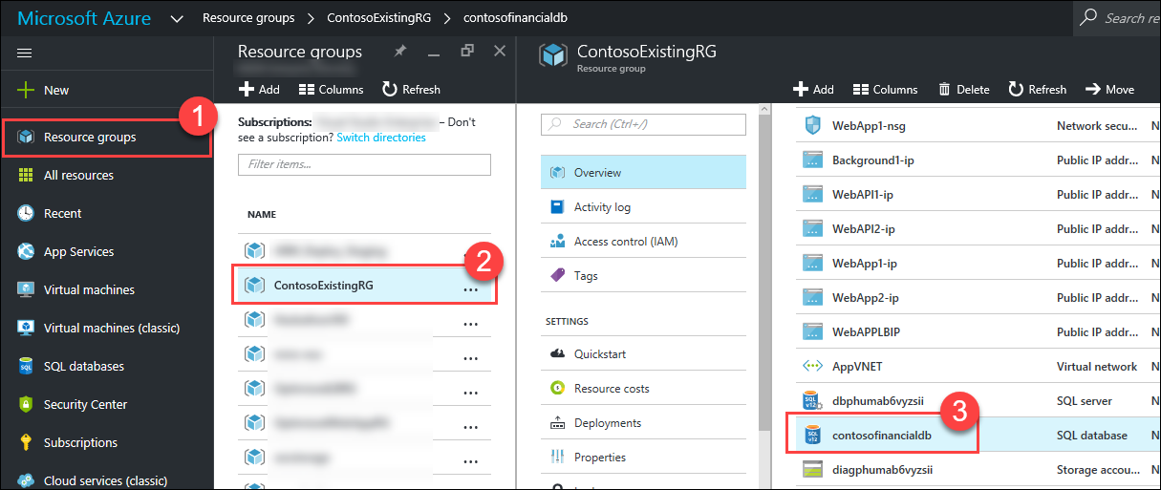
2. On the **SQL database** blade, click on **Show database connection strings**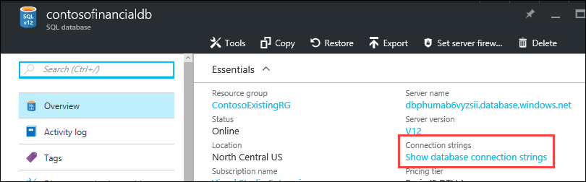
3. On the **Database connection strings** blade, copy the **ADO.NET (SQL authentication)** connection string to use later.  
     
   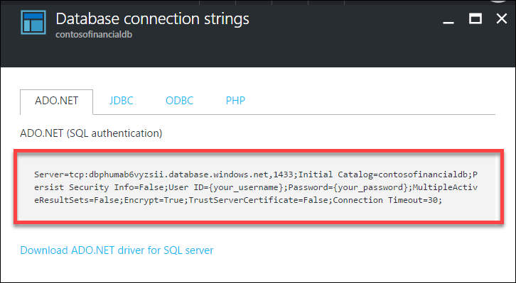
4. Click on **Resource groups**, click on the **OptimizedAPIRG** resource group, then click on the **API App** that was previously created.  
     
   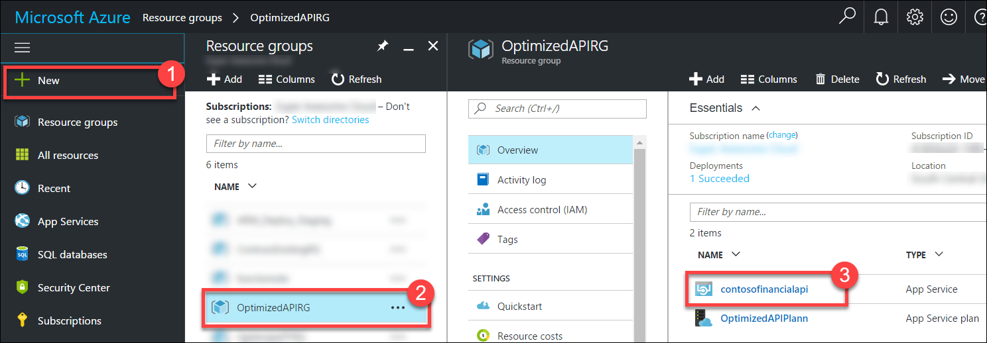
5. On the **App Service** blade, click on **Application settings**.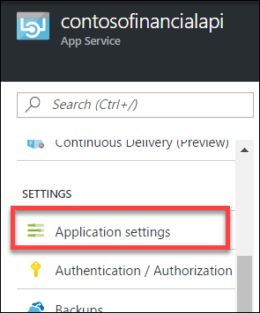
6. Scroll down to the **Connection strings** section, and add a **new** connection string with the following values:
   * Name: **TransactionDb**
   * Value: **paste in the database connection string that was copied earlier**
   * Type: **SQL Database**

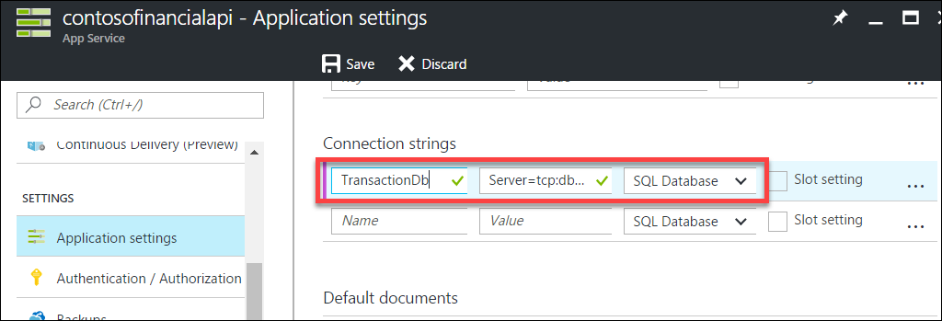

1. Replace the value **{your_username}** with **demouser** in the connection string.
2. Replace the value **{your_password}** with **demo@user123** in the connection string.
3. Click **Save**

### Step 3: Deploy API to App Service

1. From the *C:\Hackathon\Contoso.Financial*folder, open the Visual Studio Solution: **Contoso.Financial.sln**
2. In the **Solution Explorer** window, expand the **API** folder, then right-click the **Contoso.Financial.Api**, and click on **Publish…**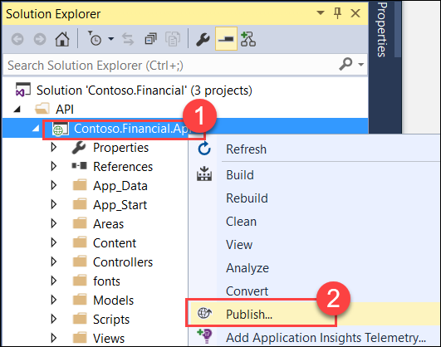
3. On the **Publish** dialog, click on **Microsoft Azure App Service**.  
   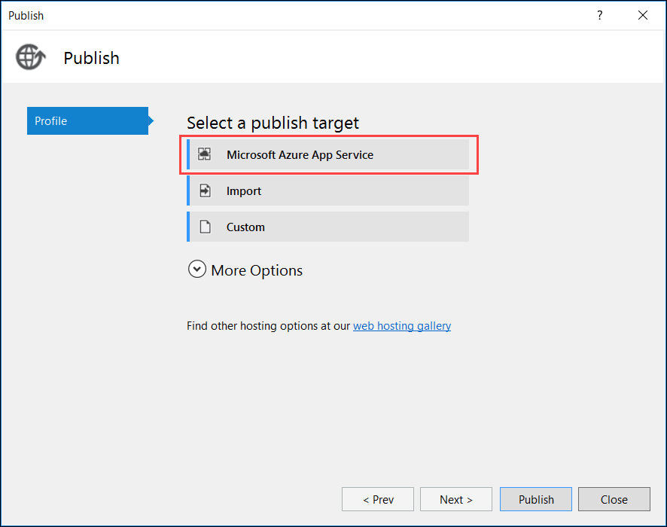
4. In the top-right corner of the **App Service** dialog, make sure your account is selected. If it is not, click on the button and add it.  
   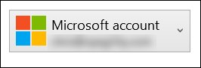
5. Expand the **OptimizedAPIRG** resource group, and select the **App Service Web App**, then click **OK**  
     
   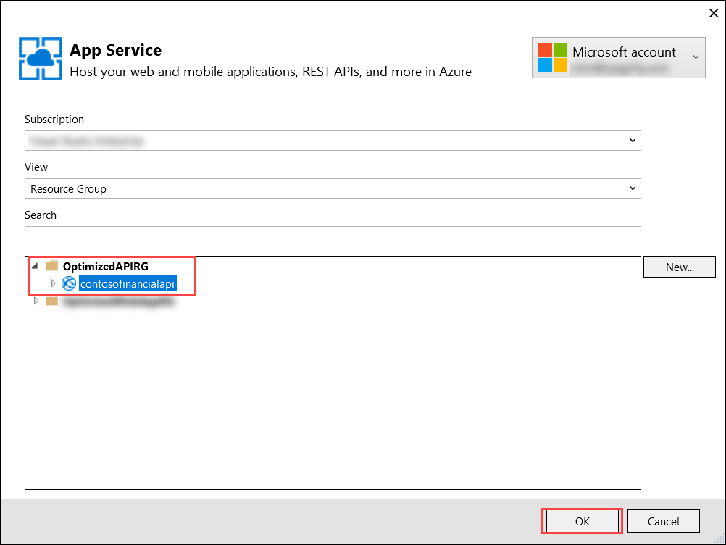
6. Click the **Publish** button.  
     
   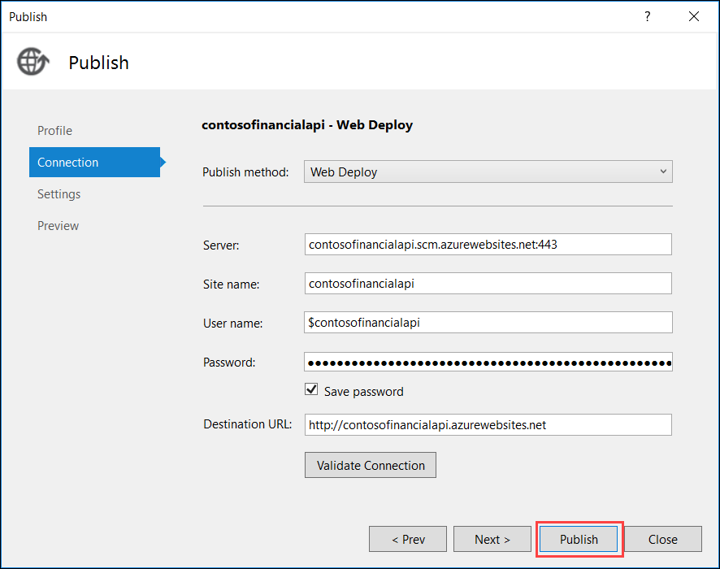
7. Once the deployment has completed, Visual Studio will automatically open a new browser window navigating to the **App Service** app. This window can be closed.  
     
   

## Exercise 5: Migrate Web App Tier to App Service

### Overview

In the migration of IaaS to PaaS, the Front-end Web App Tier of Contoso Financials application needs to be migrated to run in an Azure App Service Web App without requiring any code changes to the application.

### Help references

|  |  |
| --- | --- |
| Azure Web Apps overview | <https://azure.microsoft.com/en-us/documentation/articles/app-service-web-overview/> |
| Deploy an ASP.NET web app to Azure App Service, using Visual Studio | <https://azure.microsoft.com/en-us/documentation/articles/web-sites-dotnet-get-started/> |
| Configure web apps in Azure App Service | <https://azure.microsoft.com/en-us/documentation/articles/web-sites-configure/> |

### Step 1: Create App Service for Web App Tier

1. From the Azure Management portal <http://portal.azure.com>, using a new tab or instance, click on **+New**, then **Web + Mobile**, and then click on **Web App**.  
   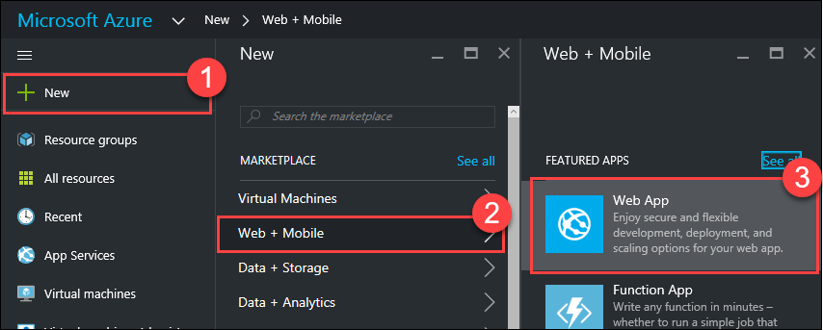
2. On the **Web App** blade, enter the following values:
   * App name: **enter a unique name**
   * Resource Group: **OptimizedWebAppRG**
   * App Insights: **Off**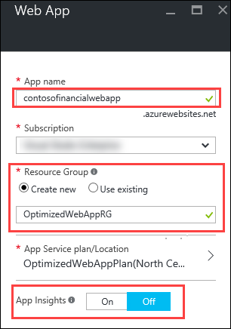
3. Click on **App Service plan/Location**, then **Create New**, and fill in the following values:
   * App Service plan: **OptimizedWebAppPlan**
   * Location: **North Central US**
   * Pricing tier: **S1 Standard**

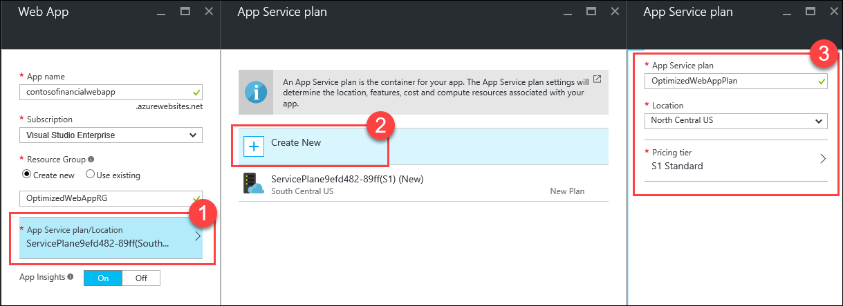

1. Click **OK**
2. Click **Create**

### Step 2: Setup App Settings

1. Click on **Resource groups**, click on the **OptimizedWebAppRG** resource group, then click on the **Web App**.  
   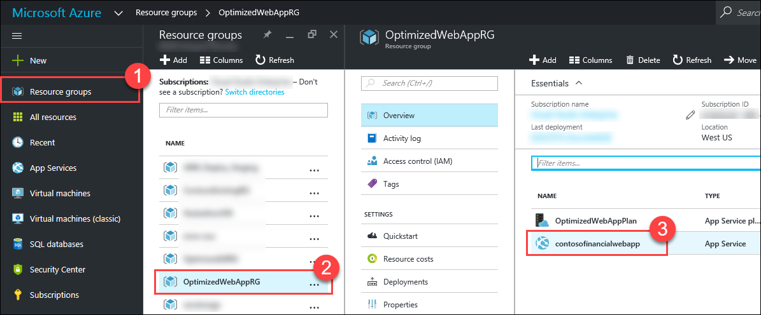
2. On the **Web App** blade, click on **Application settings**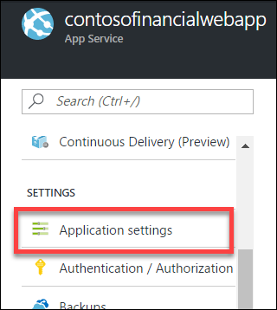
3. Scroll down to the **App settings** section, and create a **new** app setting with the following values:
   * Key: **transactionAPIUrl**
4. Value: **paste in the URL of the App Service API App that is hosting the API Tier.**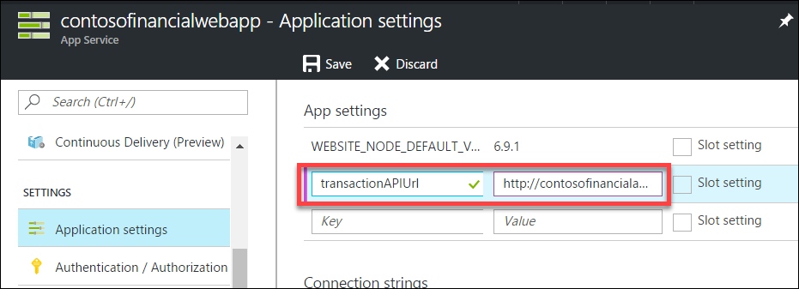
5. Click **Save**

### Step 3: Deploy App to Web App

1. From the *C:\Hackathon\Contoso.Financial* folder, open the Visual Studio Solution: **Contoso.Financial.sln**
2. In the **Solution Explorer** window, expand the **Web** folder, then right-click the **Contoso.Financial.Website** project, and click on **Publish…**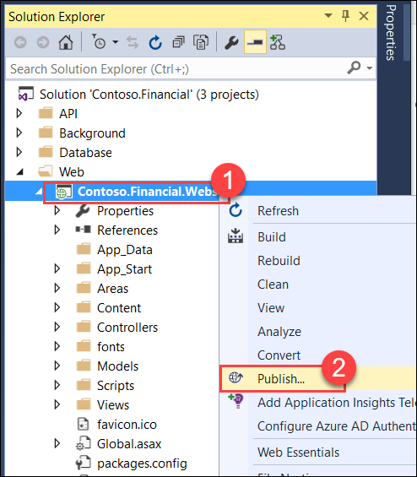
3. On the **Publish** dialog, click on **Microsoft Azure App Service**.  
   
4. In the top-right corner of the **App Service** dialog, make sure your account is selected. If it is not, click on the button and add it.  
   
5. Expand the **OptimizedWebAppRG** resource group, and select the **Web App**, then click **OK**.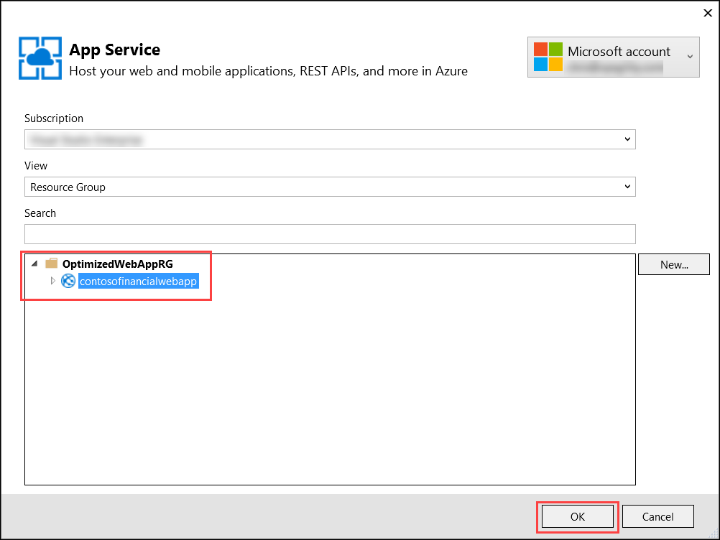
6. Click **Publish**  
   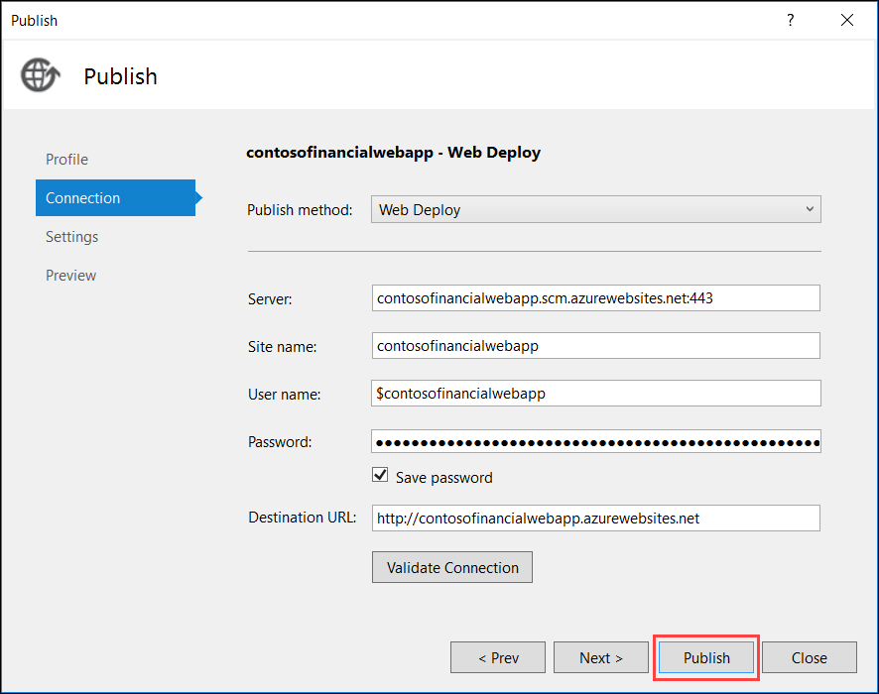
7. Once the deployment has completed, Visual Studio will automatically open a new browser window navigating to the **Web App**.

### Step 4: Add Web App to Traffic Manager

1. From the Azure Management portal <http://portal.azure.com>, using a new tab or instance, click on **Resource groups**, click on the **OptimizedTFRG** resource group, then click on the **Traffic Manager**.  
     
   
2. On the **Traffic Manager profile** blade, click on **Endpoints**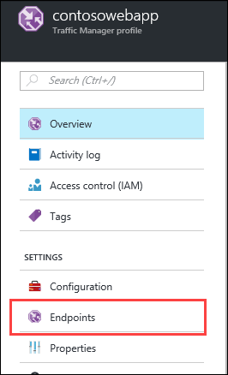
3. Click **Add**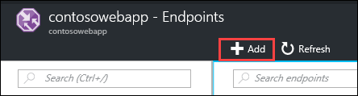
4. On the **Add endpoint** blade, enter the following values:
   * Type: **Azure endpoint**
   * Name: **Web App**
   * Target resource type: **App Service**

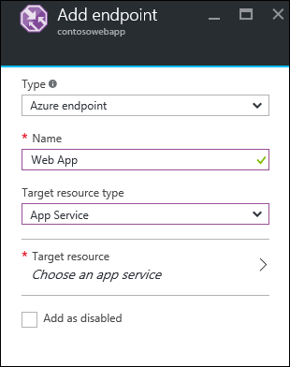

1. Click on **Choose an app service**  
   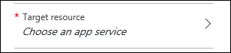
2. Click on the **Web App** that was previously created.  
   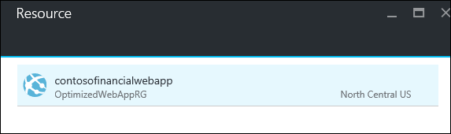
3. Click **OK**
4. Click on the **External Load Balancer** Endpoint.  
   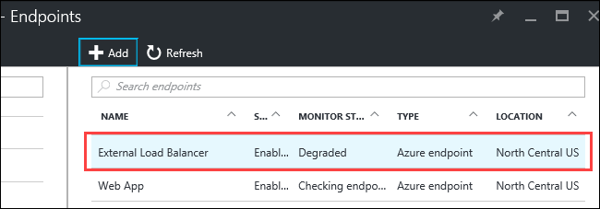
5. Click the **Edit** button  
   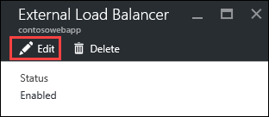
6. Select the **Disabled Status**, then click **Save**

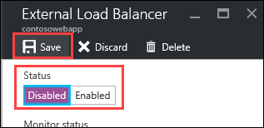

1. On the **Traffic Manager**, click on **Overview**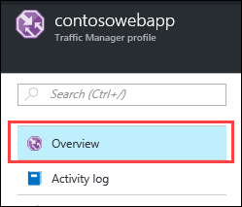
2. Click on the **DNS name** to open it in a new browser window.  
   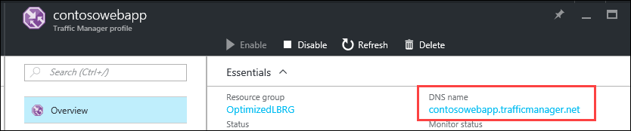
3. Verify the site still loads as expected.  
   
4. Click on **Endpoints**
5. Click on the **External Load Balancer** endpoint.  
   
6. Click **Delete**  
   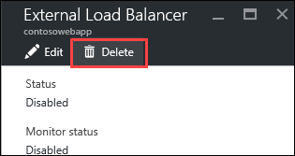
7. On the **Delete Traffic Manager endpoint** prompt, click **Yes**  
   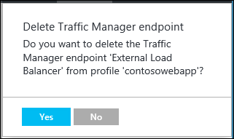

After this step, the Web App Tier’s Load Balancer and VMs will no longer receive requests through the Traffic Manager.

### Step 5: Take down Web App and API VMs

1. Click on **Resource groups**, and then click on the **ContosoExistingRG** resource group.
2. Click on the **WebApp1** virtual machine.
3. Click the **Stop** button.  
   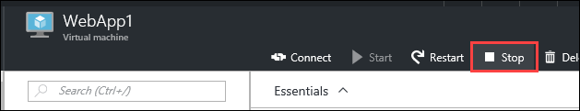
4. On the **Stop this virtual machine** prompt, click **Yes**.  
   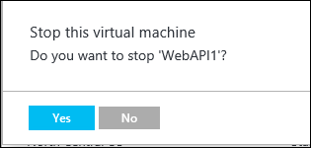
5. Repeat the last three steps for the **WebApp2, WebAPI1,** and **WebAPI2** virtual machines.
6. Open a new browser window / tab, navigate to the URL for the **Traffic Manager endpoint**.
7. **Login** to the Web App and ensure it loads all data as expected to test out the **App Service** hosted Web App and API tiers are functioning properly.  
     
   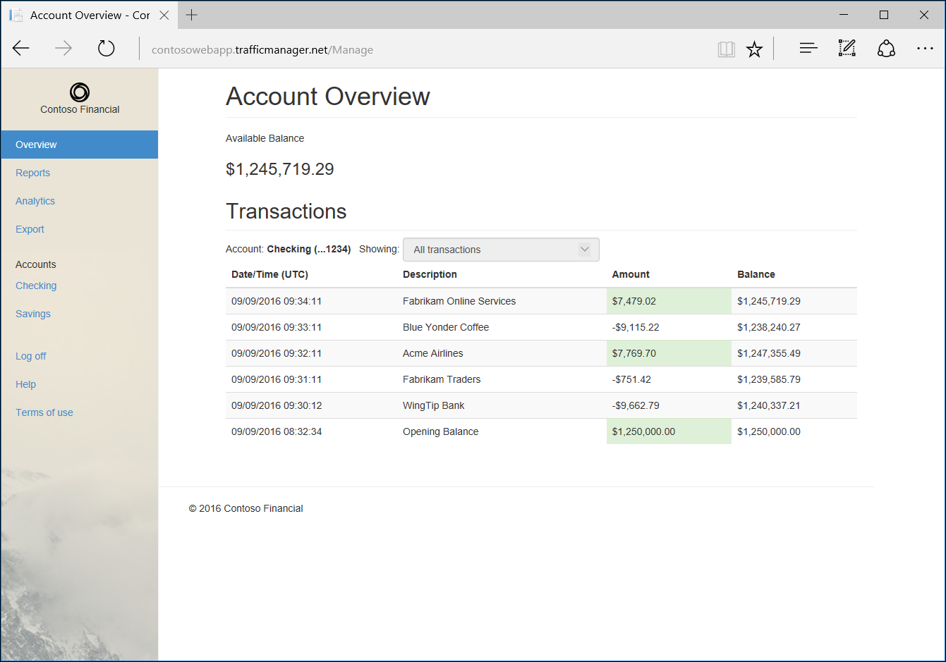
8. After validating the app, close the browser window.

## Exercise 6: Migrate Background Tier to App Service

### Overview

In the migration of IaaS to PaaS, the Background Tier (written as a console app) of Contoso Financials application needs to be migrated to run in an Azure App Service Web Job without requiring any code changes to the application.

### Help references

|  |  |
| --- | --- |
| Using WebJobs in Azure App Service | <https://azure.microsoft.com/en-us/documentation/articles/app-service-webjobs-readme/> |
| Run Background tasks with WebJobs | <https://azure.microsoft.com/en-us/documentation/articles/web-sites-create-web-jobs/> |
| Configure web apps in Azure App Service | <https://azure.microsoft.com/en-us/documentation/articles/web-sites-configure/> |

### Step 1: Create App Service for Background Tier

1. From the Azure Management portal <http://portal.azure.com>, using a new tab or instance, click on **+New**, then **Web + Mobile**, and then click on **Web App**.  
   
2. On the **Web App** blade, enter the following values:
   * App name: **enter a unique name**
   * Resource Group: **OptimizedBackgroundRG**
   * App Insights: **Off**  
     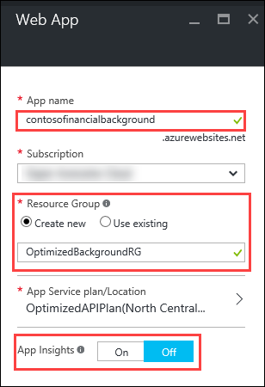
3. Click on **App Service plan/Location**, then **Create New**, and fill in the following values:
   * App Service plan: **OptimizedBackgroundPlan**
   * Location: **North Central US**
   * Pricing tier: **S1 Standard**  
     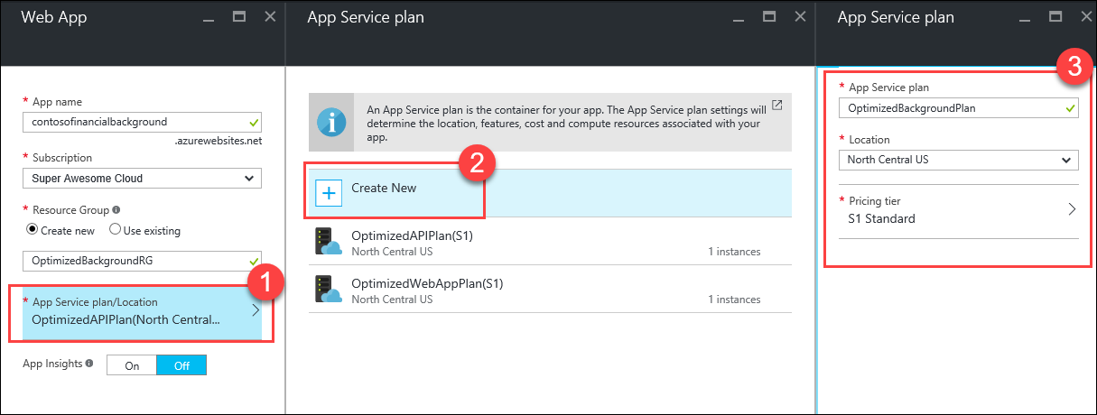
4. Click **OK**
5. Click **Create**

### Step 2: Setup App Settings

1. Click on **Resource groups**, click on the **OptimizedBackgroundRG** resource group, then click on the **App Service**.  
     
   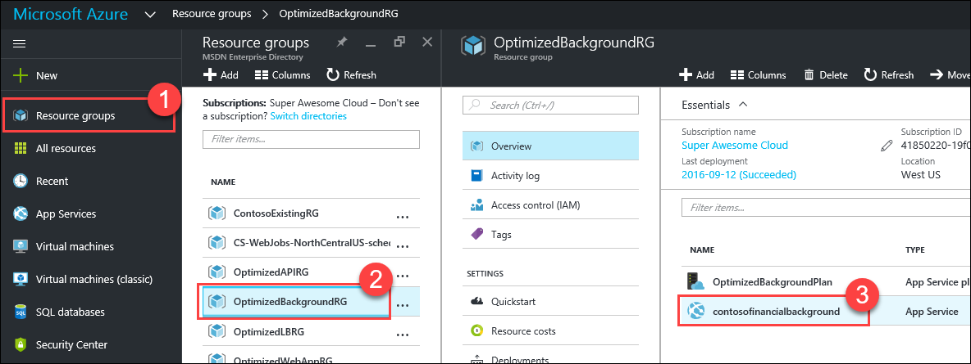
2. On the **Web app** blade, click on **Application settings**.  
     
   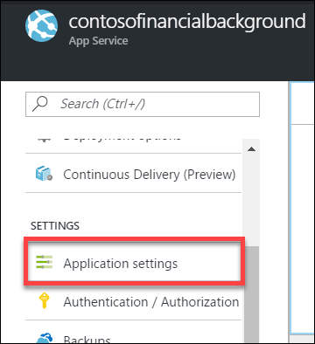
3. Scroll down to the **Connection strings** section, and add a **new** connection string with the following values:
   * Name: **TransactionDb**
   * Value: **past in the database connection string that was copied earlier**
   * Type: **SQL Database**

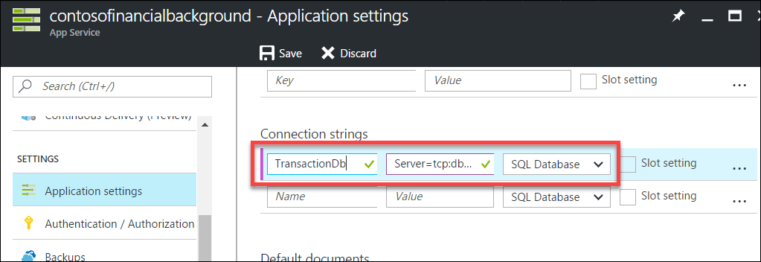

1. Replace the value **{your_username}** with **demouser** in the connection string.
2. Replace the value **{your_password}** with **demo@pass123** in the connection string.
3. Click **Save**

### Step 3: Deploy App to App Service

1. From the *C:\Hackathon\Contoso.Financial* folder, open the Visual Studio Solution: **Contoso.Financial.sln**
2. In the **Solution Explorer** window, expand the **Background** folder, then right-click the **Contoso.Financial.Background** project, and click on **Publish as Azure WebJob…**  
     
   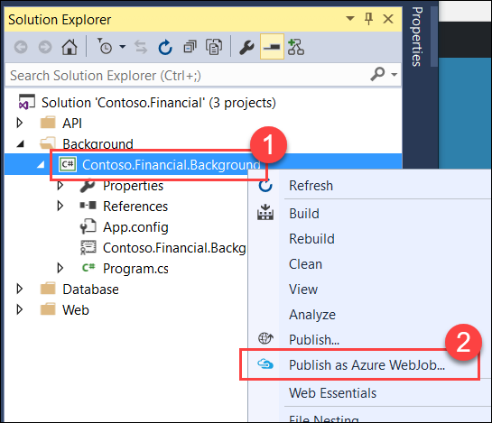
3. On the **Add Azure WebJob** dialog, enter the following values:
   * WebJob name: **Background1**
   * WebJob run mode:  **Run on a Schedule**
   * Recurrence: **Recurring Job**
   * No end date: **Check this box**
   * Recur every: **1 Hours**

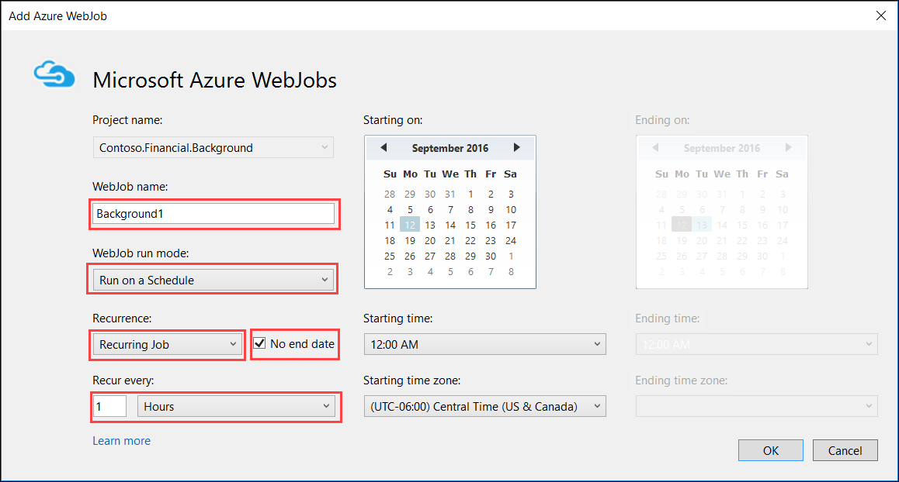

1. Click **OK**
2. On the **Publish** dialog, click on **Microsoft Azure App Service**  
   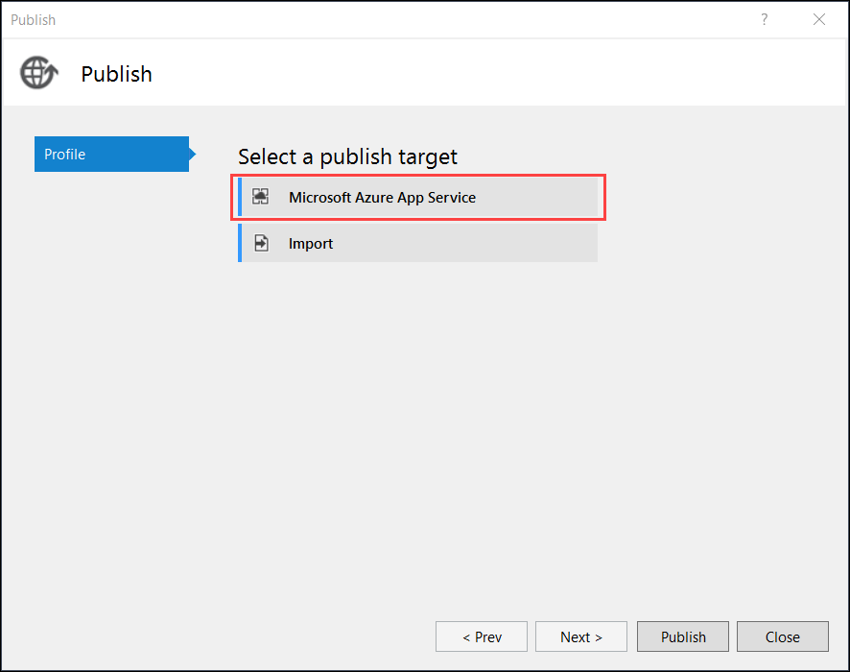
3. In the top-right corner of the **App Service** dialog, make sure your account is selected. If it is not, click on the button and add it.  
   
4. Expand the **OptimizedBackgroundRG** resource group, and select the **App Service Web App**, then click **OK**.  
     
   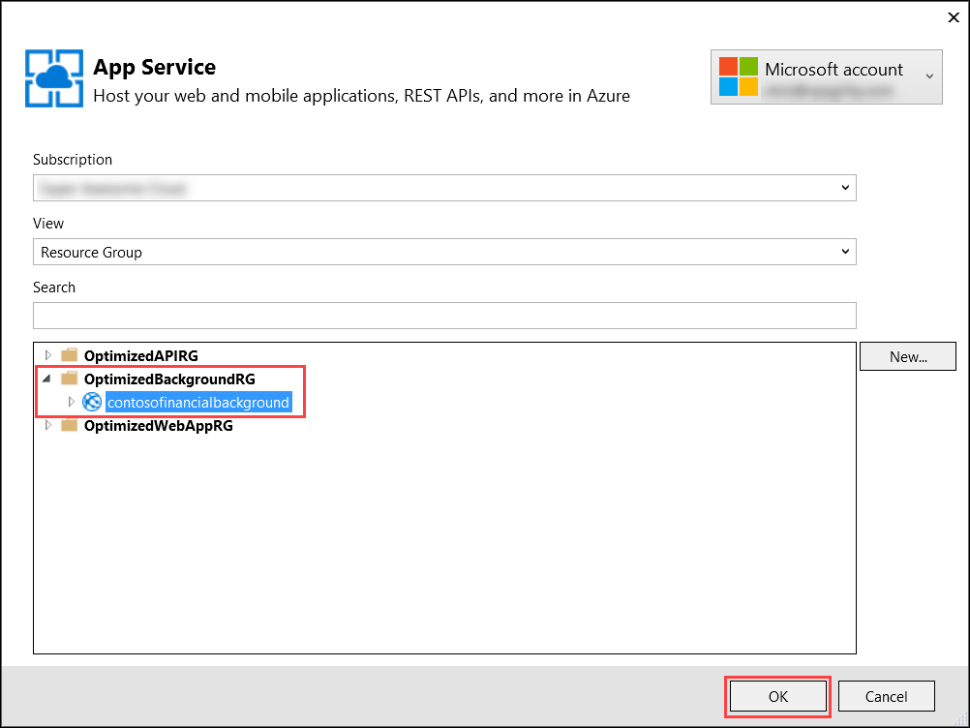
5. Click **Publish**  
   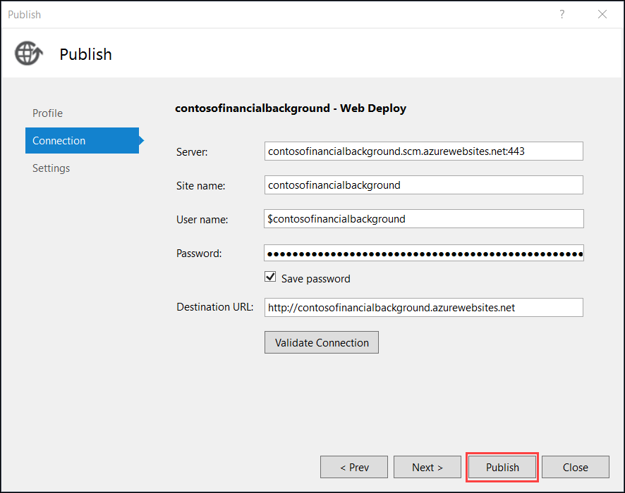
6. From the **Azure Management Portal** (<http://portal.azure.com>) using a new tab or instance, click on **Resource groups**, then click on the **CS-WebJobs-NorthCentralUS-scheduler** resource group, then click on the **WebJobs-NorthCentralUS** Scheduler Job Collection resource.  
     
   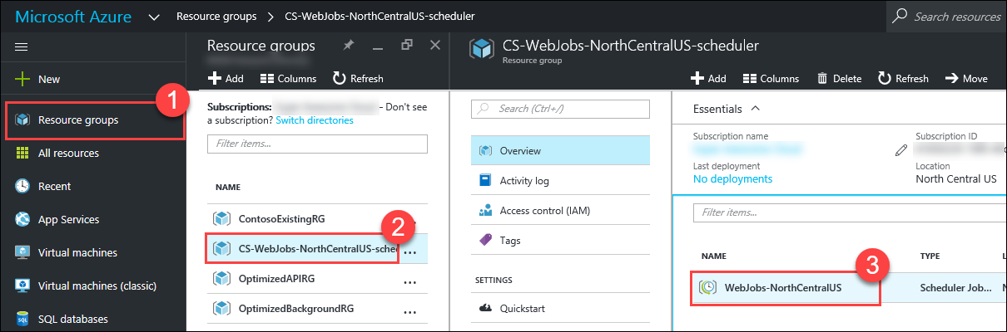
7. On the **Scheduler Job Collection** blade, click on **Pricing tier** under Settings.  
     
   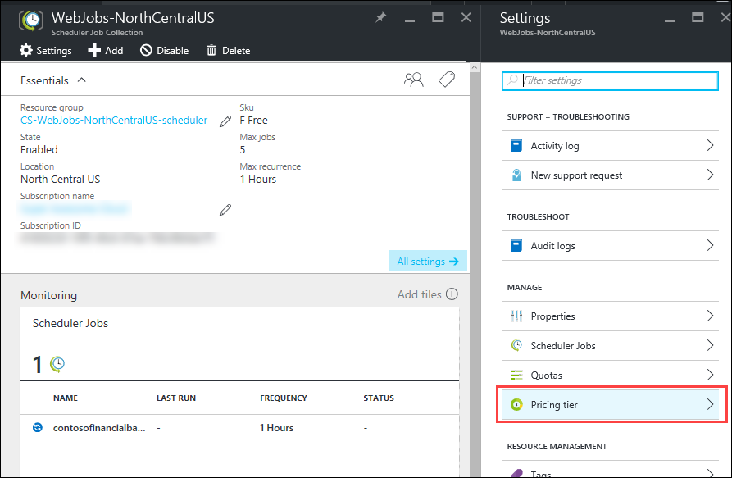
8. Select the **S Standard** pricing tier, and then click **Select**.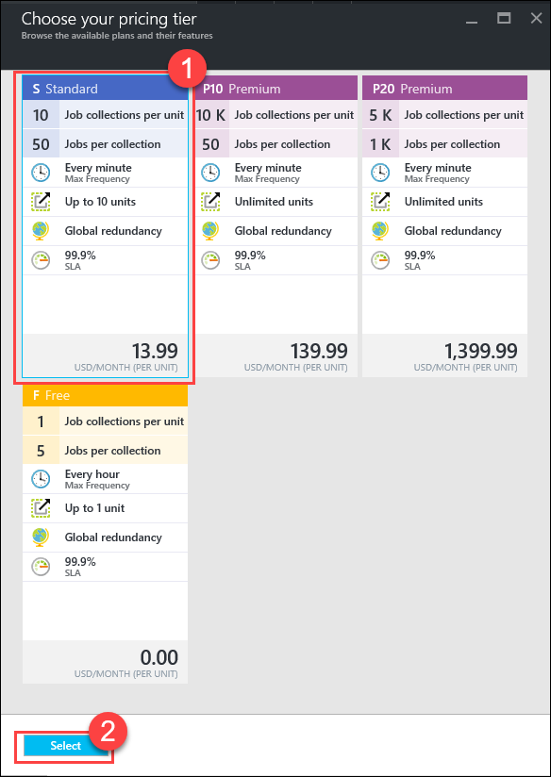
9. On the **Scheduler Job Collection** blade, click on **Quotas** under Settings.  
     
   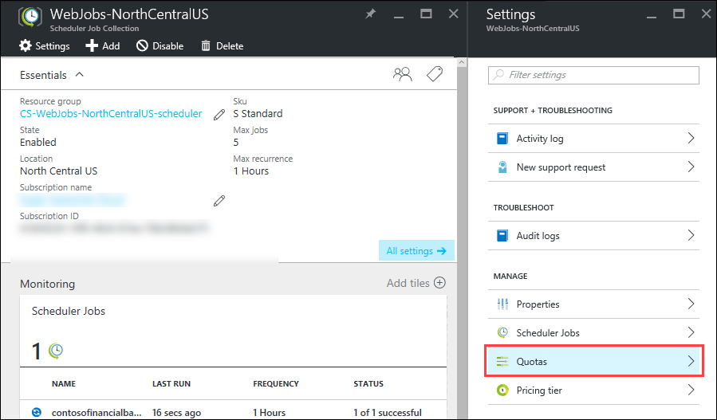
10. On the **Quotas** blade, change the **Max recurrence** to **1 Minutes**, then click **Save.**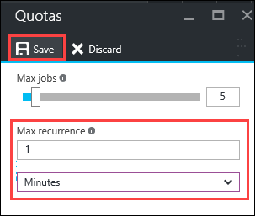
11. On the **Scheduler Job Collection** blade, click on the **contosofinancialbackground-Background1** job within the **Scheduler Jobs** tile.  
      
    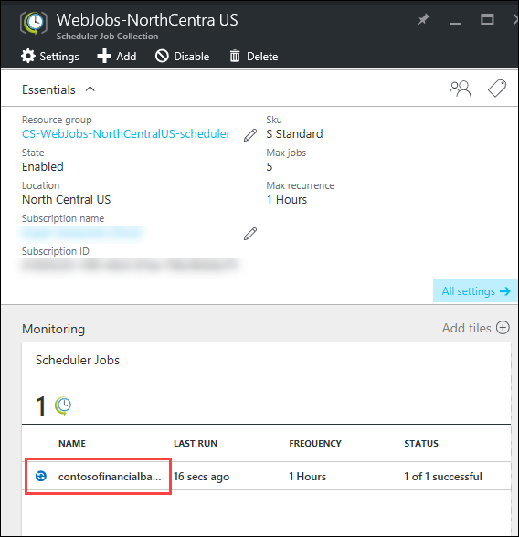
12. On the **Scheduler Job** blade, click on **Schedule** under Settings.  
      
    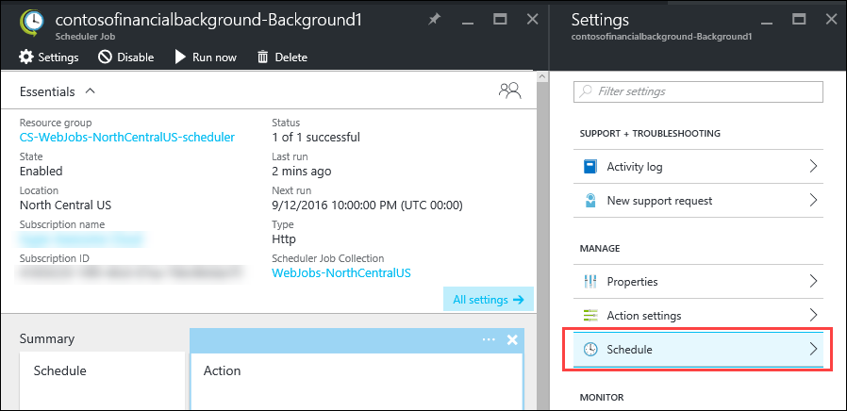
13. On the **Schedule** blade, change the **Recur every** fields to be **1 Minutes**, then click **Save**.  
      
    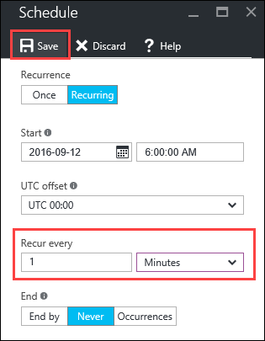
14. Wait a couple minutes, and then look the **History** tile of the **Scheduler Job** blade to verify the scheduled job is running. The **bar graph** and **successes count** will reflect that it is running.  
      
    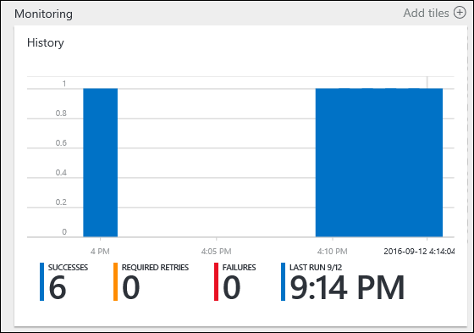
15. Open a new browser window or tab navigating to the **URL** for the **Traffic Manager** for the application, and verify the transactions generated by the background process are showing up.  
      
    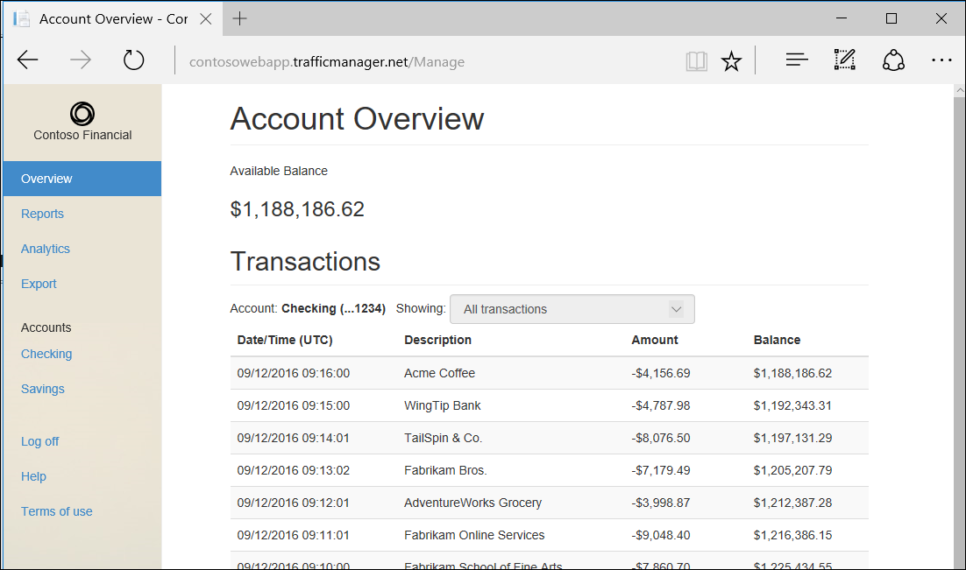

### Step 4: Take down Background Tier VM

1. From the Azure Management Portal (<http://portal.azure.com>), click on **Resource groups**, and then click on the **ContosoExistingRG** resource group.  
     
   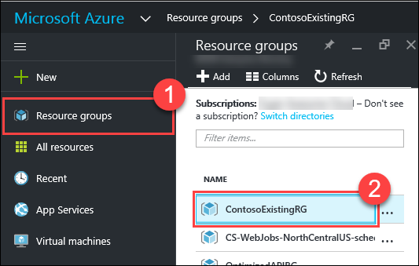
2. Click on the **Background1** virtual machine.
3. Click the **Stop** button.  
     
   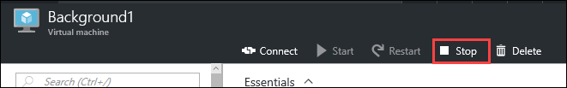
4. On the **Stop this virtual machine** prompt, click **Yes**.  
     
   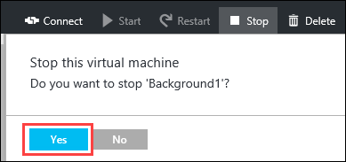

## Exercise 7: Setup SQL Database Geo-Replication

### Overview

Due to the rush into Production, the Staging SQL Database currently remains as the Production database for the application. You have been asked to implement Geo-Replication to the SQL Database in order to add the appropriate redundancy to safeguard against failures. This will both help eliminate data loss in case of a data center failure, as well as greatly reduce the potential system downtime in the event of such a failure.

### Help references

|  |  |
| --- | --- |
| Introduction to SQL Database | <https://azure.microsoft.com/en-us/documentation/articles/sql-database-technical-overview/> |
| SQL Database Active Geo-Replication | <https://azure.microsoft.com/en-us/documentation/articles/sql-database-geo-replication-overview/> |

### Step 1: Setup SQL Database Geo-Replication

1. Click on **Resource groups**, click on the **ContosoExistingRG** resource group, then click on the **contosofinancialdb** SQL Database.  
     
   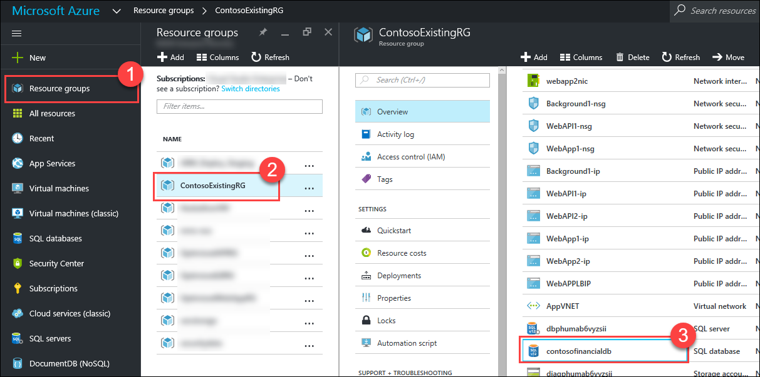
2. On the **SQL database** blade, click on **Geo-Replication**.  
     
   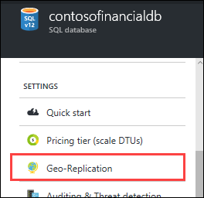
3. Click on the **Recommended Target Region** to replicate to.  
     
   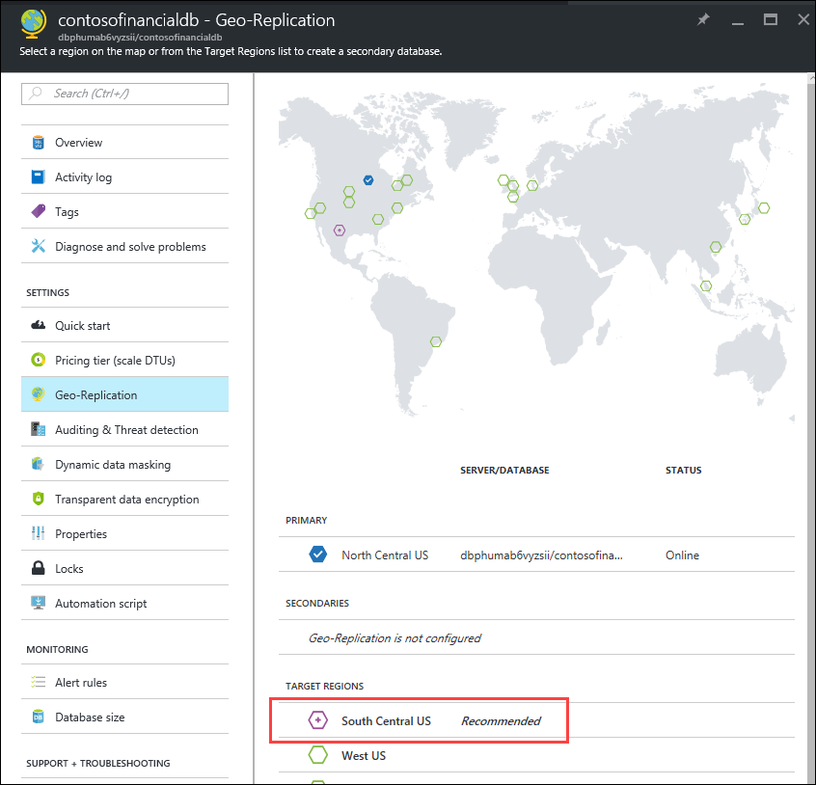
4. On the **Create secondary** blade, click on **Target server**  
   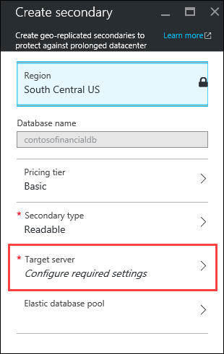
5. On the **New server** blade, enter the following values:
   * Server name: **enter a unique name**
   * Server admin login: **demouser**
   * Password: **demo@pass123**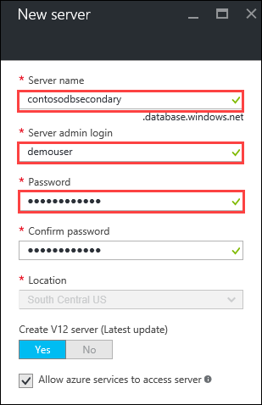
6. Click **Select**
7. Click **OK**
8. Database replication is now configured.  
     
   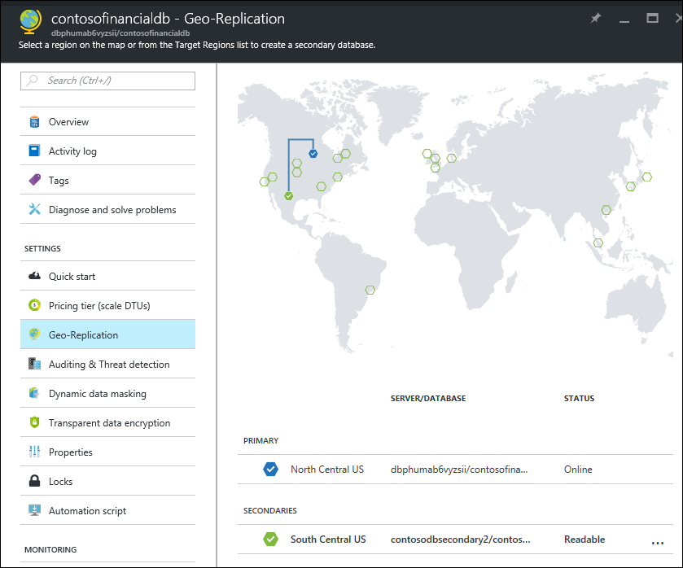

## Exercise 8: Take down old architecture / resources

### Overview

Now that the Contoso Financial application has been migrated to Azure PaaS services utilizing Azure App Service, the older, existing architecture that is no longer being used needs to be removed. Since the application has been validated to work as expected, you have been asked to delete the Azure IaaS components hosting the VM infrastructure.

### Step 1: Remove Old VM-based tiers

1. Click on **Resource groups**, and then click on the **ContosoExistingRG** resource group.
2. Delete the following resources that are hosting the OLD Web App, API, and Background tiers.
   * **BackgroundAV**
   * **WebAPIAV**
   * **Background1**
   * **WebAPI1**
   * **WebAPI2**
   * **WebApp1**
   * **WebApp2**
   * **WebAPILB**
   * **WebAppLB**
   * **background1nic**
   * **webapi1nic**
   * **webapi2nic**
   * **webapp1nic**
   * **webapp2nic**
   * **Background1-ip**
   * **WebAPI1-ip**
   * **WebAPI2-ip**
   * **WebApp1-ip**
   * **WebApp2-ip**
   * **WebAPPLBIP**
   * **AppVNET**
   * **Background1-nsg**
   * **WebAPI1-nsg**
   * **WebApp1-nsg**  
       
     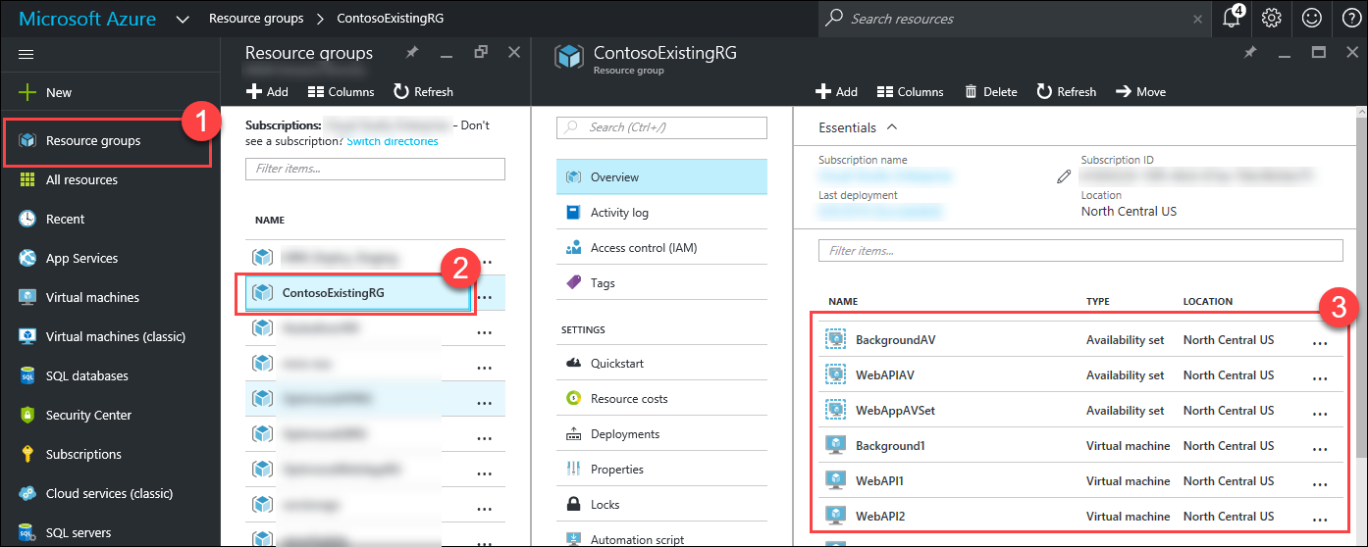

Be sure not to delete the Azure SQL Database (**contosofinancialdb**) and Azure SQL Server. These are still in use!

1. Delete the **Storage Accounts** with the following name prefixes:
   * **diag**
   * **disk**  
     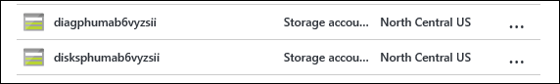
2. Once all the resources for the VMs that are no longer needed have been deleted / removed from the **ContosoExistingRG** resource group, the only resources left in that resource group should be the **SQL Databases and Servers**.  
     
   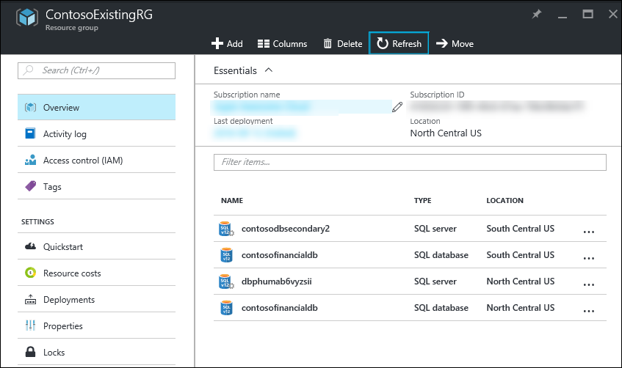

## Exercise 9: Setup European Web App Tier Instance

### Overview

As Contoso Financial expands into Europe, they need to handle the additional growth while maintaining the same application performance. While to fully support global scale, there are pieces of the application that will need to be refactored, you have been asked to setup a secondary region for the Front-end Web App Tier in the Azure North Europe region.

### Help references

|  |  |
| --- | --- |
| Azure Web Apps overview | <https://azure.microsoft.com/en-us/documentation/articles/app-service-web-overview/> |
| Deploy an ASP.NET web app to Azure App Service, using Visual Studio | <https://azure.microsoft.com/en-us/documentation/articles/web-sites-dotnet-get-started/> |
| Configure web apps in Azure App Service | <https://azure.microsoft.com/en-us/documentation/articles/web-sites-configure/> |

### Step 1: Create European App Service

1. From the Azure Management portal <http://portal.azure.com>, using a new tab or instance, click on **+New**, then **Web + Mobile**, and then click on **Web App**.  
     
   
2. On the **Web App** blade, enter the following values:
   * App name: **enter a unique name**
   * Resource Group: **OptimizedWebAppEuropeRG**
   * App Insights: **Off**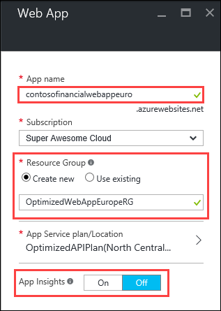
3. Click on **App Service plan/Location**, then **Create New**, and fill in the following values:
   * App Service Plan: **OptimizedWebAppEuropePlan**
   * Location: **North Europe**
   * Pricing tier: **S1 Standard**  
       
     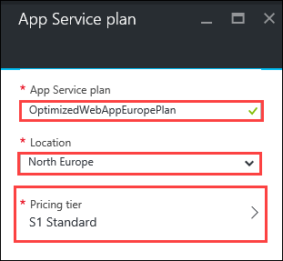
4. Click **OK**
5. Click **Create**

### Step 2: Set App Settings

1. Click on **Resource groups**, click on the **OptimizedWebAppEuropeRG** resource group, then click on the **Web App**.  
     
   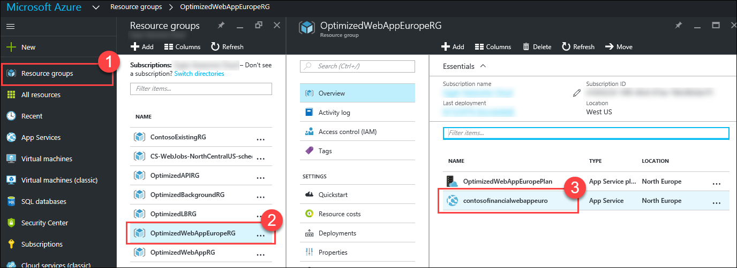
2. On the **Web App** blade, click on **Application settings**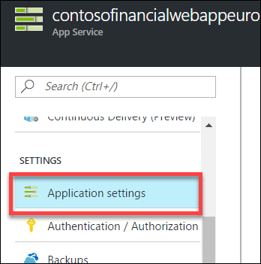
3. Scroll down to the **App settings** section, and create a **new** app setting with the following values:
   * Key: **transactionAPIUrl**
   * Value: **paste in the URL of the App Service Web App that is hosting the API tier. This is should be set to the same value that was used for the Web App Tier in North Central US region.**

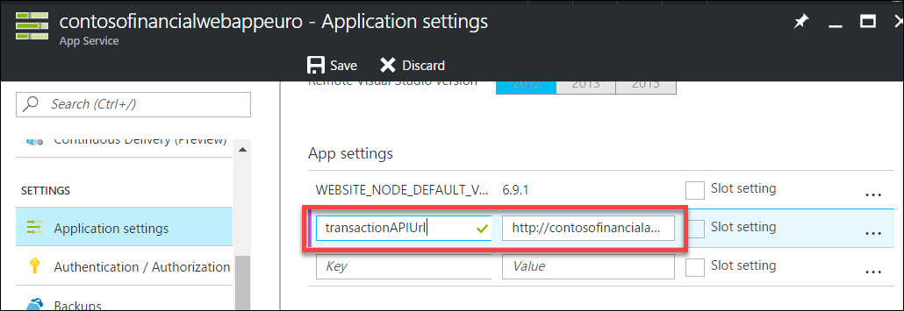

1. Click **Save**

### Step 3: Deploy Web App to European Region

1. From the *C:\Hackathon\Contoso.Financial*folder, open the Visual Studio Solution: **Contoso.Financial.sln**
2. In the **Solution Explorer** window, expand the **Web** folder, then right-click the **Contoso.Financial.Website** project, and click on **Publish…**  
     
   
3. On the **Publish** dialog, click **Microsoft Azure App** Service.  
   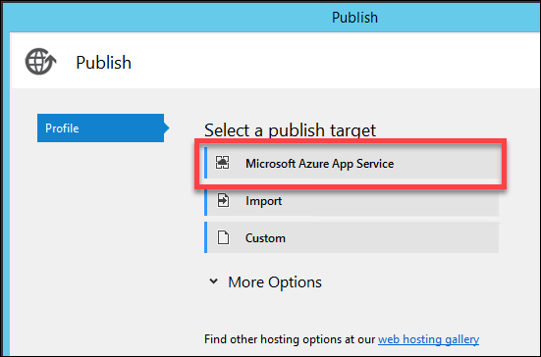
4. On the **App Service** dialog, expand the **OptimizedWebAppEuropeRG** resource group, select the **Web App** in the North Europe region, and then click **OK**.  
   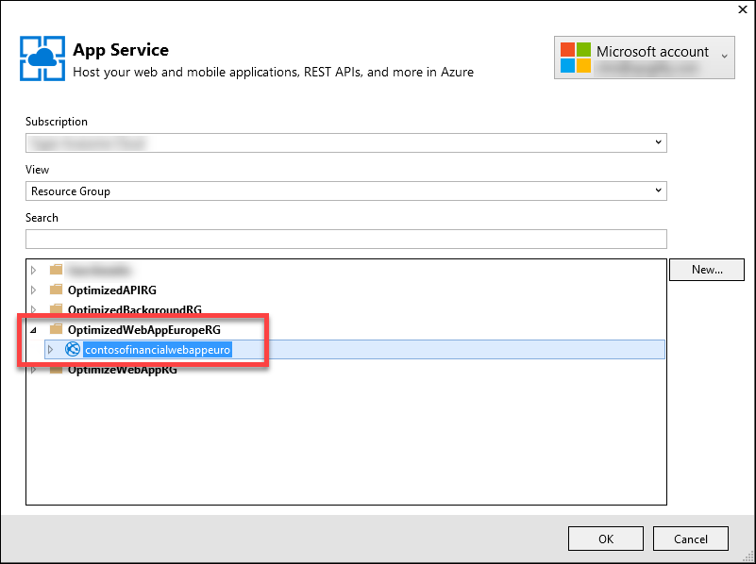
5. Click **Publish**  
     
   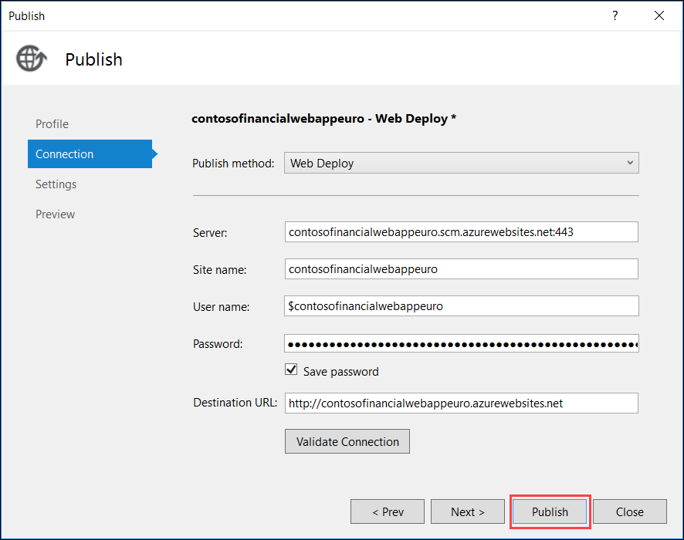
6. Once the deployment has completed, Visual Studio will automatically open a new browser window navigating to the **Web App**.  
     
   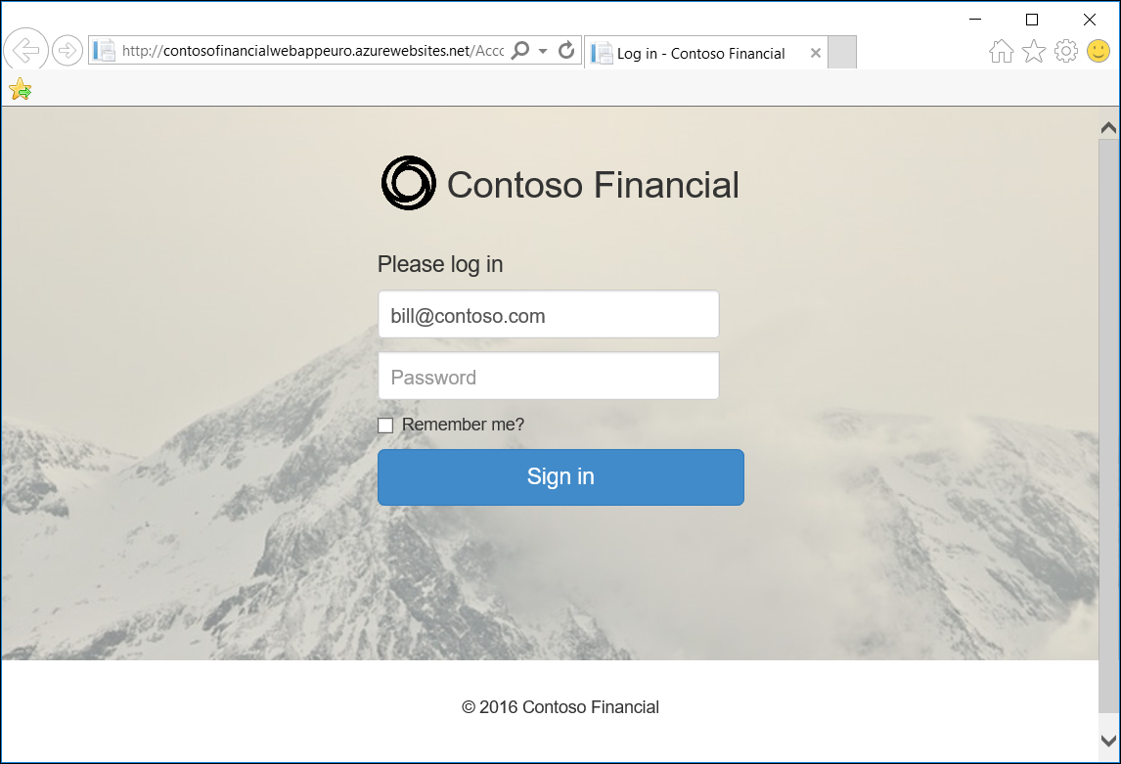

### Step 4: Add European Region to Traffic Manager

1. From the Azure Management Portal <http://portal.azure.com>, using a new tab or instance, click on **Resource groups**, click on the **OptimizedTFRG** resource group, then click on the **Traffic Manager**.  
   
2. On the **Traffic Manager profile** blade, click on **Endpoints**  
   
3. Click **Add**  
     
   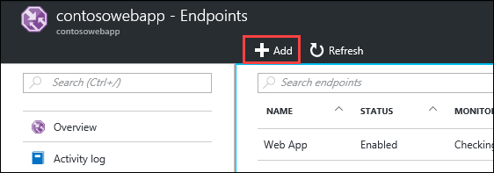
4. On the **Add endpoint** blade, enter the following values:
   * Type: **Azure endpoint**
   * Name: **Web App (Europe)**
   * Target resource type: **App Service**

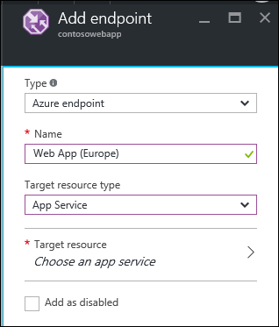

1. Click on **Choose an app service**  
   
2. Click on the **Web App** that was created in the **North Europe** region.  
     
   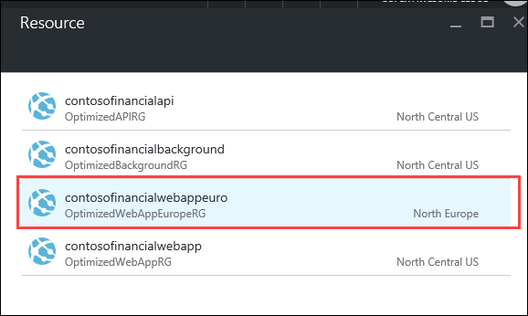
3. Click **OK**
4. Click on **Overview**  
     
   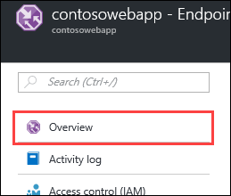
5. On the **Traffic Manager profile** blade, click on the **DNS name** to open a new browser window navigating to the **Traffic Manager** endpoint.  
     
   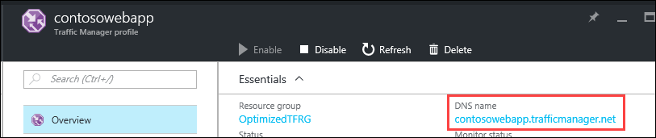
6. Login to the Web App and ensure it loads all data as expected to test out the App Service hosted Web App and API App tiers are functioning properly.  
     
   
7. After validating the app, close the browser window.